

**THE UNIVERSITY OF TEXAS AT ARLINGTON, TEXAS  
DEPARTMENT OF ELECTRICAL ENGINEERING**

**EE 5321 - 001**

**OPTIMAL CONTROL**

**HW # 3**

**ASSIGNMENT**

**by**

**SOUTRIK MAITI**

**1001569883**

**Presented to**

**Prof. Michael Niestroy**

**Feb 22,2018**

**Problem 1:**

**a)**

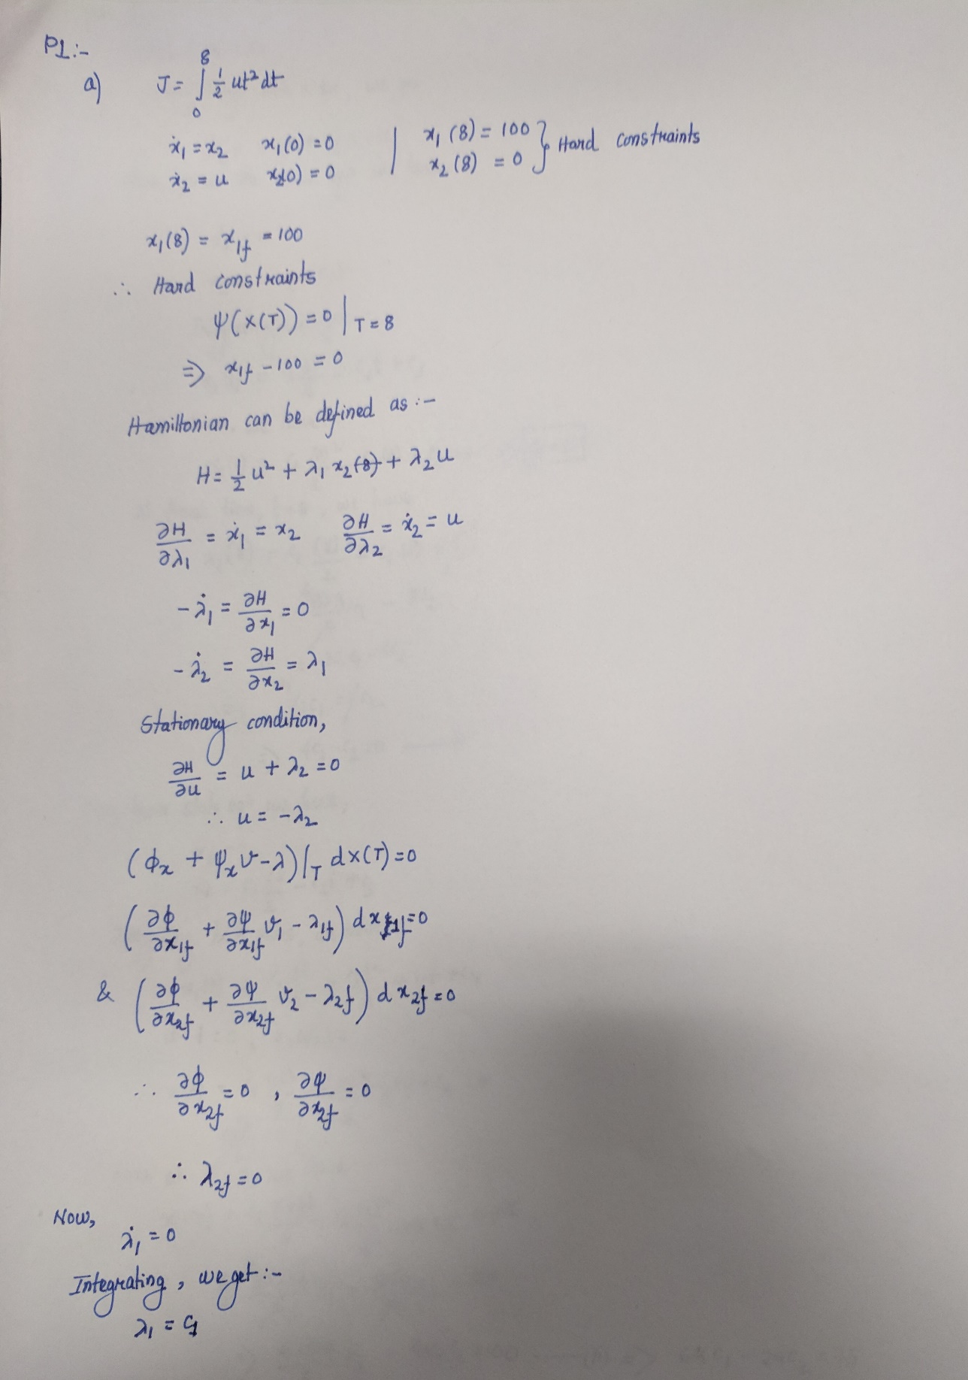

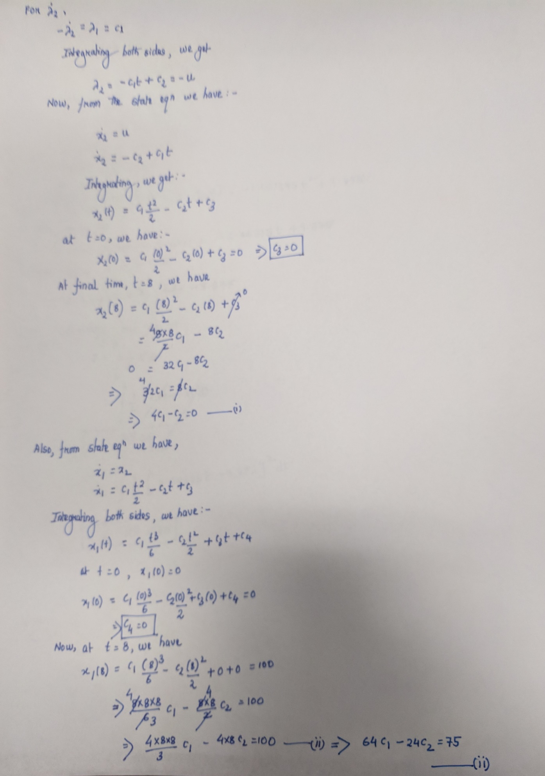

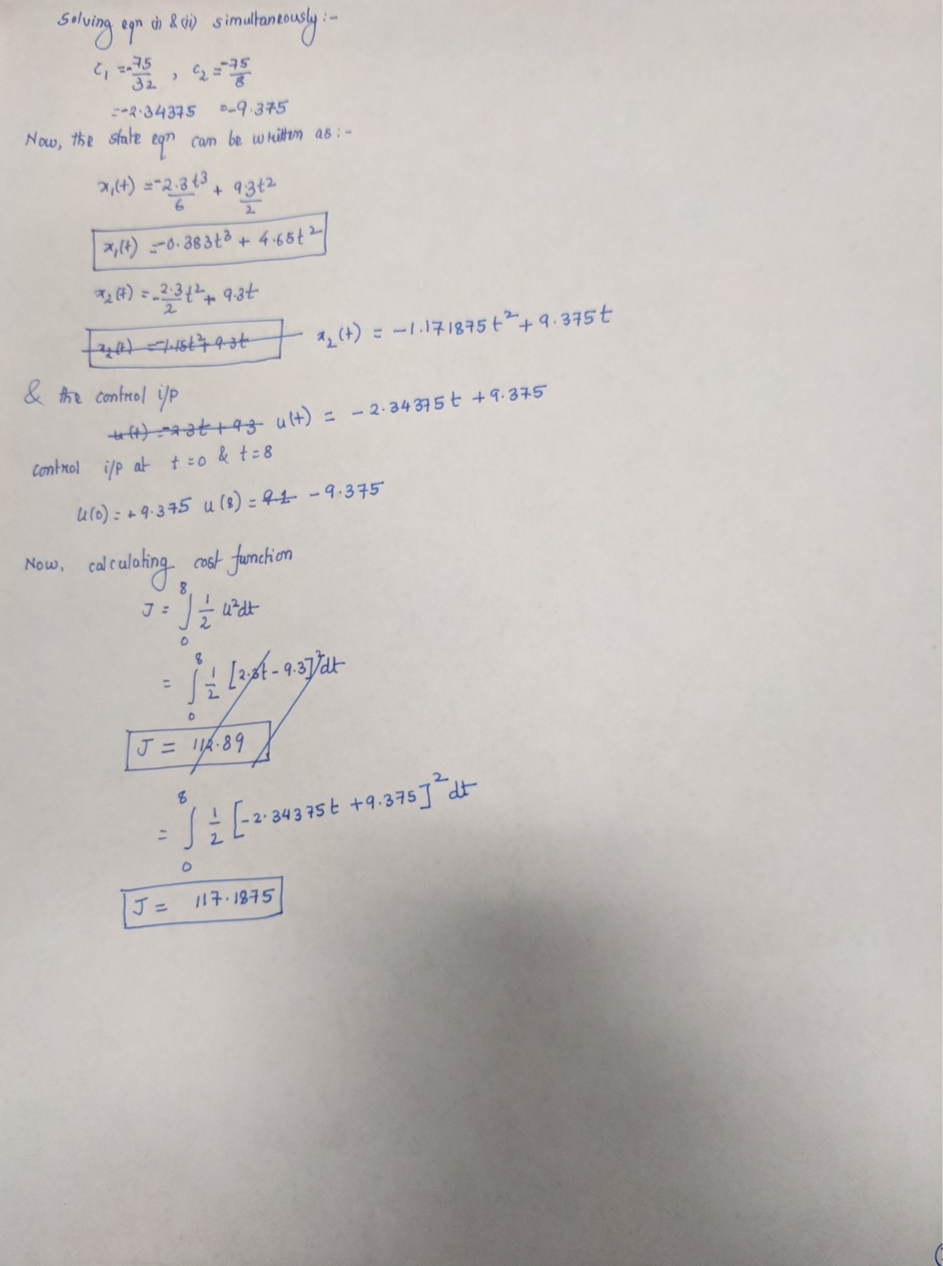

**b)** *Simulink Diagram:*

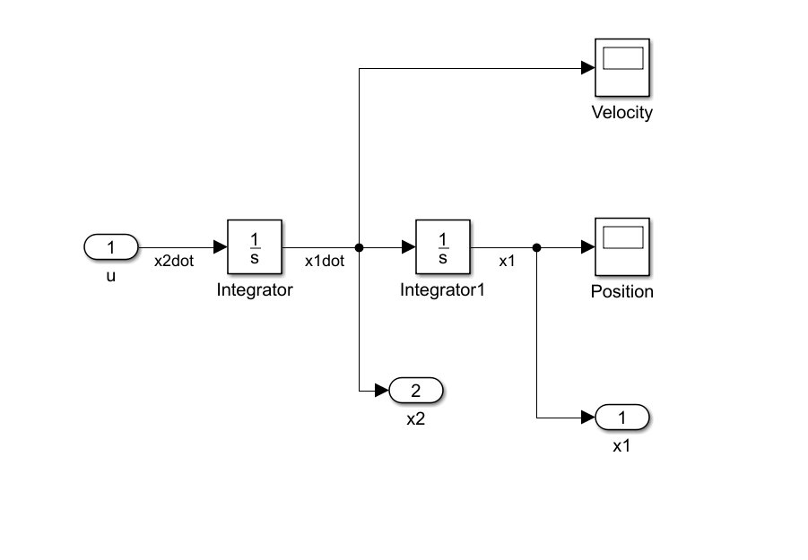

*MATLAB CODE:*

clear all;

clc;

t = 0:0.1:8;

%sim with initial control

u = ones(length(t),1);

u(41:end) = -1;

[t0,y0] = sim('hw3p1b',t',[],[t' u]);

plot(t',u,'*');

title('Initial Control Input')

xlabel('Time');

ylabel('u');

%Constrained optimization

lb = ones(81,1)*(-100);

ub = ones(81,1)*(100);

options = optimset('Display','iter','PlotFcns','optimplotx');

[uf,cost] = fmincon('hw3_cost',u,[],[],[],[],lb,ub,'hw3_constraint',options);

%sim with optimal control

[tout,yout] = sim('hw3p1b',t',[],[t' uf]);

figure;

plot(tout,uf,'o');

title('Optimal Control Input')

xlabel('Time');

ylabel('u*');

%Plotting state time histories

figure;

plot(tout,yout(:,1));

grid;

xlabel('Time');

ylabel('State x1');

figure;

plot(tout,yout(:,2));

grid;

xlabel('Time');

ylabel('State x2');

*Cost function:*

function cost = hw3_cost(u)

cost = 0.5*0.1*trapz(u.*u);

end

*Constraint function:*

function [cineq,ceq] = hw3_constraint(u)

cineq = [];

t = 0:0.1:8;

[tout,yout] = sim('hw3p1b',t',[],[t' u]);

%Hard Constraints

ceq(1) = 100 - yout(end,1);

ceq(2) = yout(end,2);

end

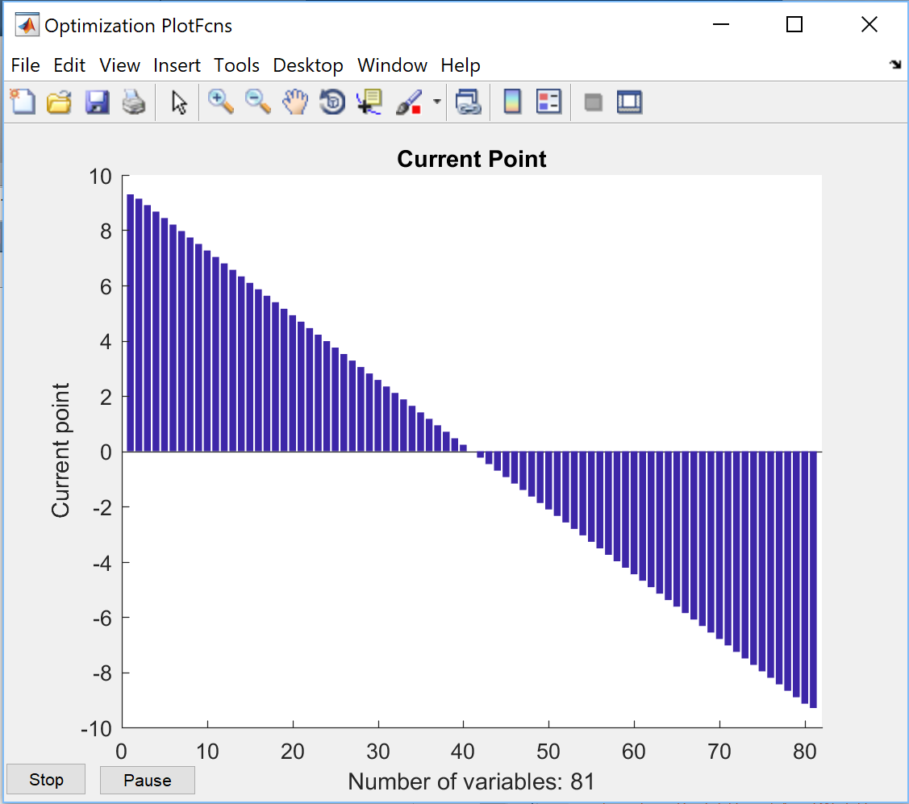

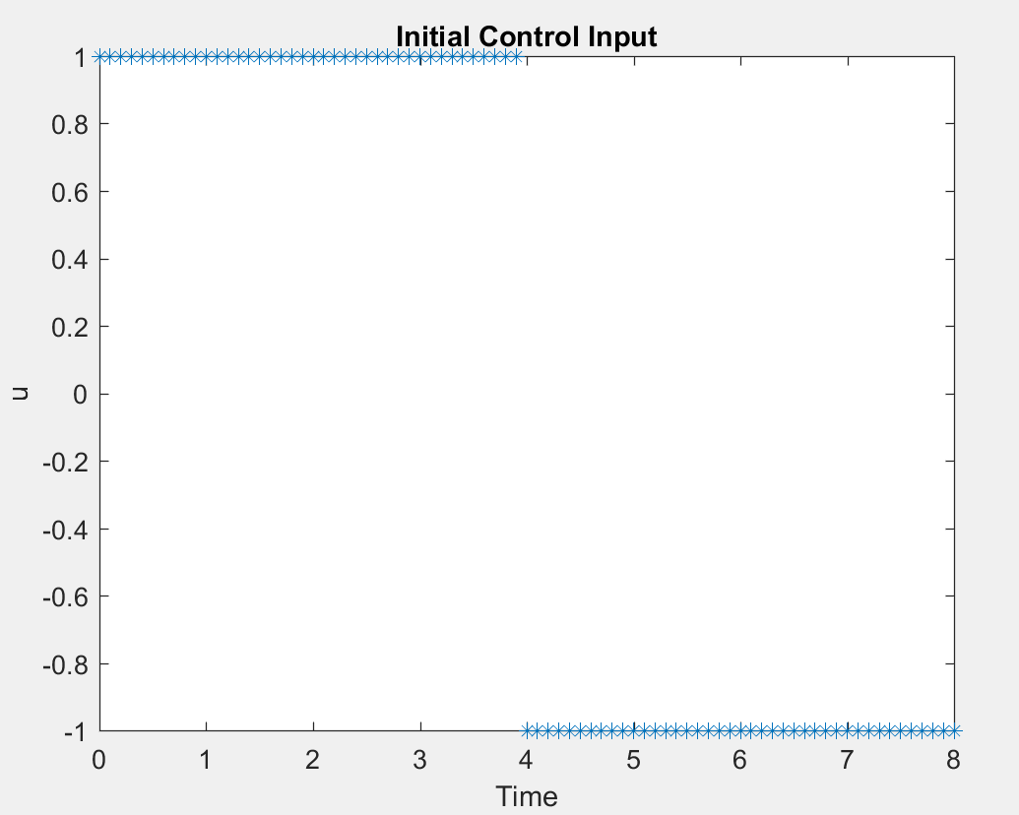

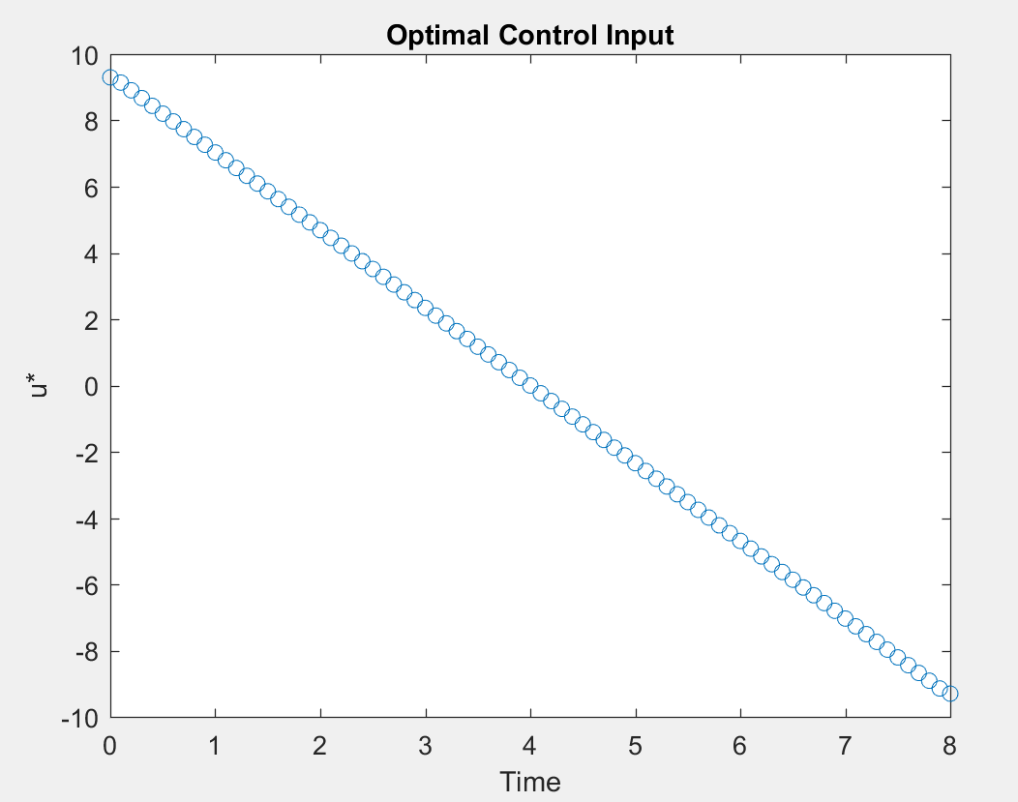

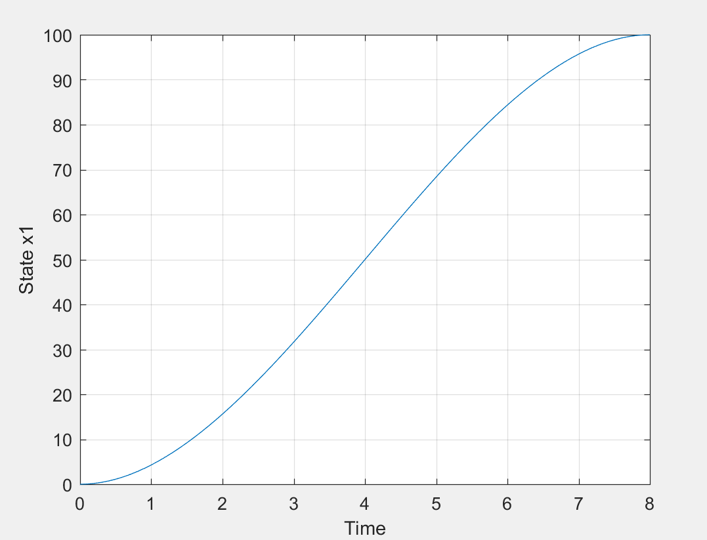

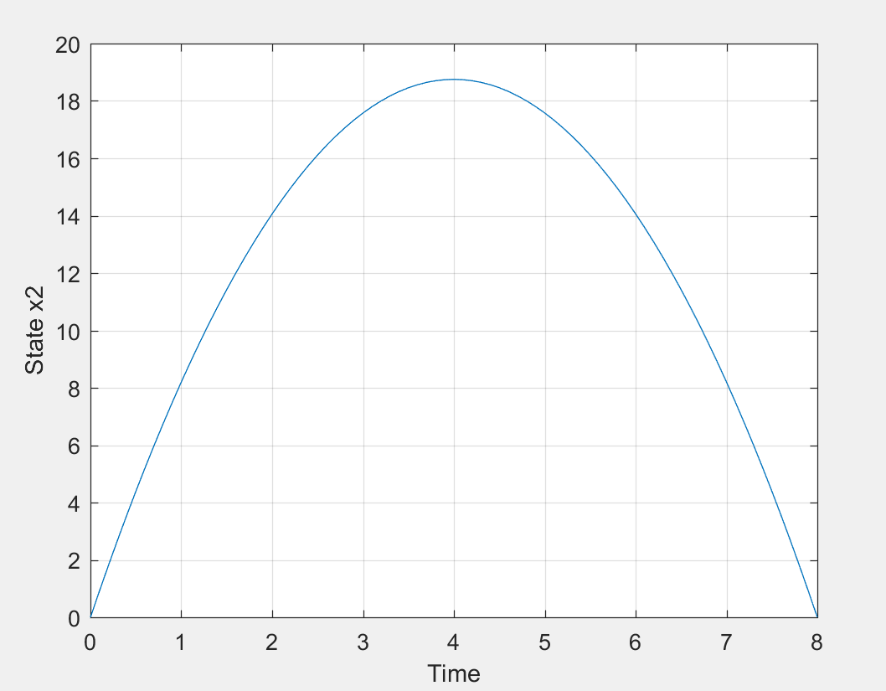

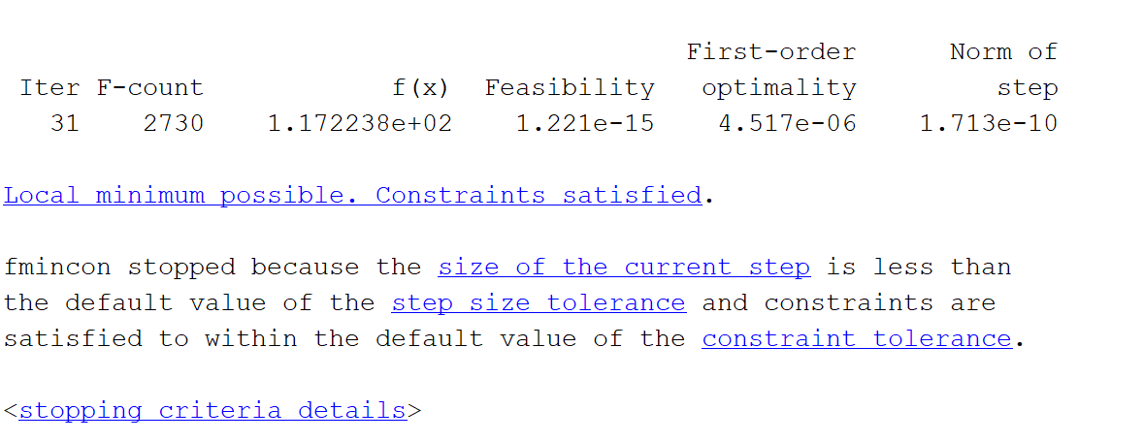

*The value of the cost calculated analytically is 117.1875 which is approximately equal to 117.2238 as calculated from MATLAB.*

**c)** According to problem the constraint function can be modified as :

function [cineq,ceq] = hw3pc_constraint(u)

cineq = [];

t = 0:0.1:8;

[tout,yout] = sim('hw3p1b',t',[],[t' u]);

%Hard Constraints

cineq = 100-yout(end,1);

ceq = cineq;

end

Results:

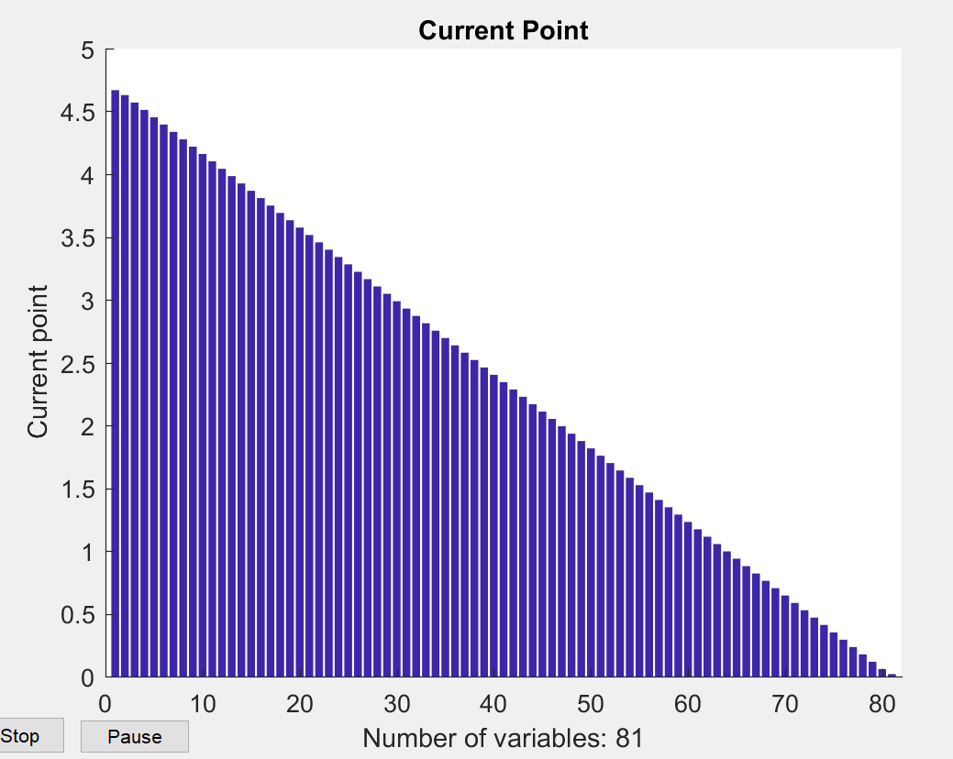

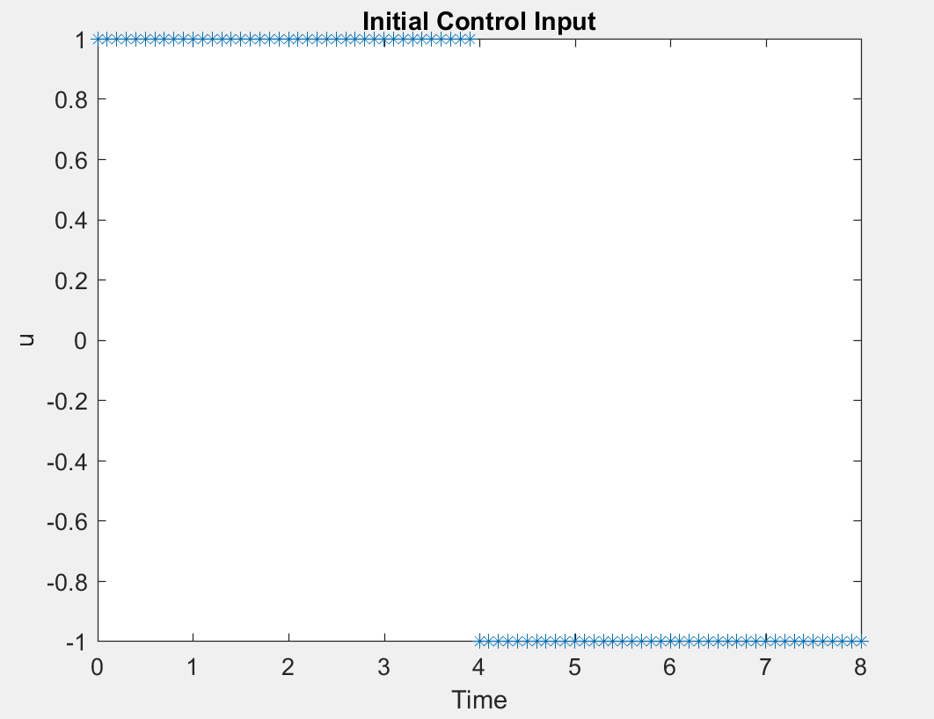

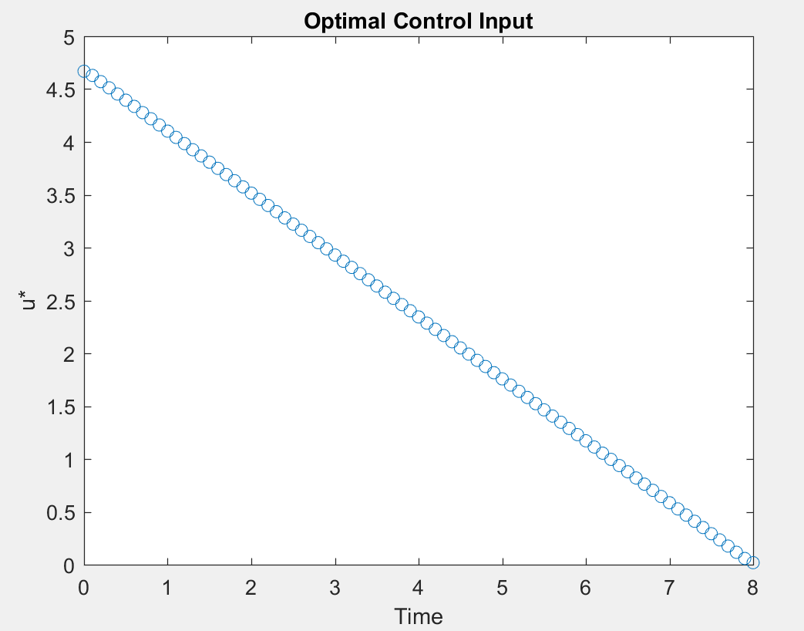

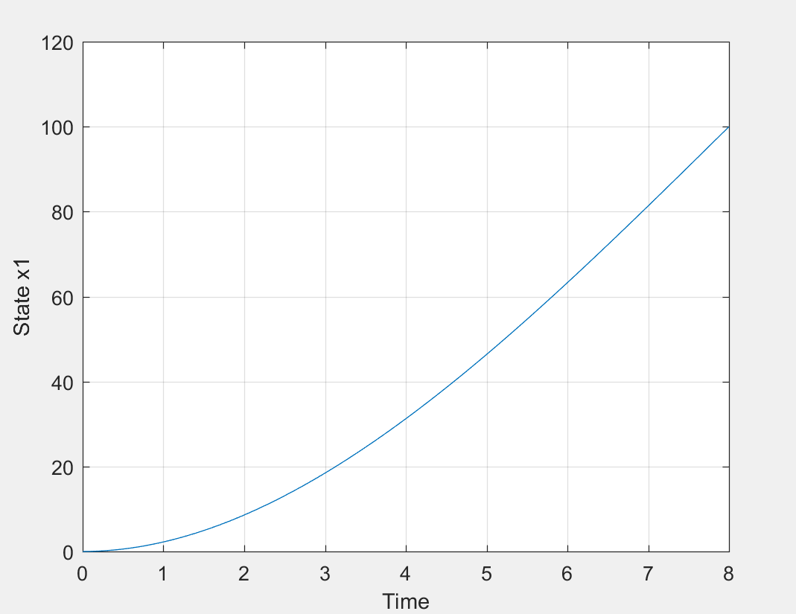

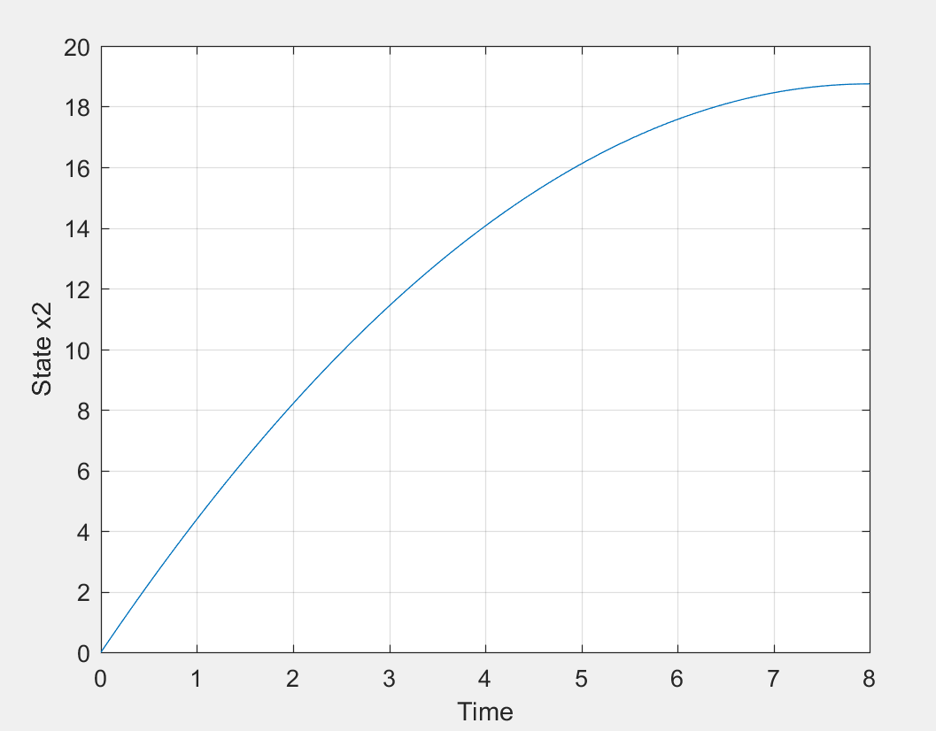

*The time taken to reach the solution increased as we changed the constraints.*

**Problem 2:**

*Simulink diagram:*

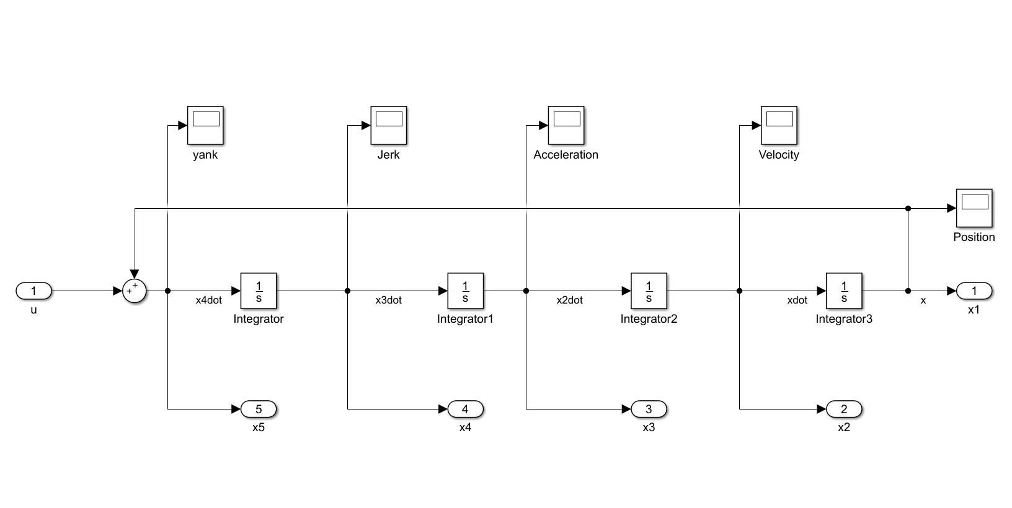

1. *MATLAB code:*

clear all;

clc;

t = 0:0.1:5;

% Sim with Initial control

u = 0.1 * ones(length(t),1);

u(26:end) = -0.1;

[t0,y0] = sim('hw3p2',t',[],[t' u]);

plot(t',u,'*');

title('Initial Control Input')

xlabel('Time');ylabel('u');

% Constrianed Optimization

lb = ones(51,1)*(-100);

ub = ones(51,1)*100;

options = optimset('Display','iter','PlotFcns','optimplotx');

[uf,cost] = fmincon('hw3p2cost',u,[],[],[],[],lb,ub,'hw3p2constraint',options);

% Sim with Optimal Control

[tout,xout,yout] = sim('hw3p2',t',[],[t' uf]);

figure;

plot(tout,uf,'o');

title('Optimal Control input')

xlabel('Time');ylabel('u*');

% Plotting State time histories

figure(2);

plot(tout,yout(:,1));

grid; xlabel('Time'); ylabel('Position x1');title('Position');

figure(3);

plot(tout,yout(:,2));

grid; xlabel('Time'); ylabel('Velocity x2');title('Velocity');

figure(4);

plot(tout,yout(:,3));

grid; xlabel('Time'); ylabel('Acceleration x3');title('Acceleration');

figure(5);

plot(tout,yout(:,4));

grid; xlabel('Time'); ylabel('Jerk x4');title('Jerk');

figure(6);

plot(tout,yout(:,5));

grid; xlabel('Time'); ylabel('Yank x5');title('Yank');

*Cost function:*

function cost = hw3p2cost(u)

cost = 0.5 * 0.1 * trapz(u.*u);

end

*Constraint function with only Position as a hard constraint:*

function [cineq,ceq] = hw3p2constraint(u)

cineq = [];

t = 0:0.1:5;

[tout,xout,yout] = sim('hw3p2',t',[],[t' u]);

% Position Hard Contraints

ceq(1) = 15 - yout(end,1);

Result:

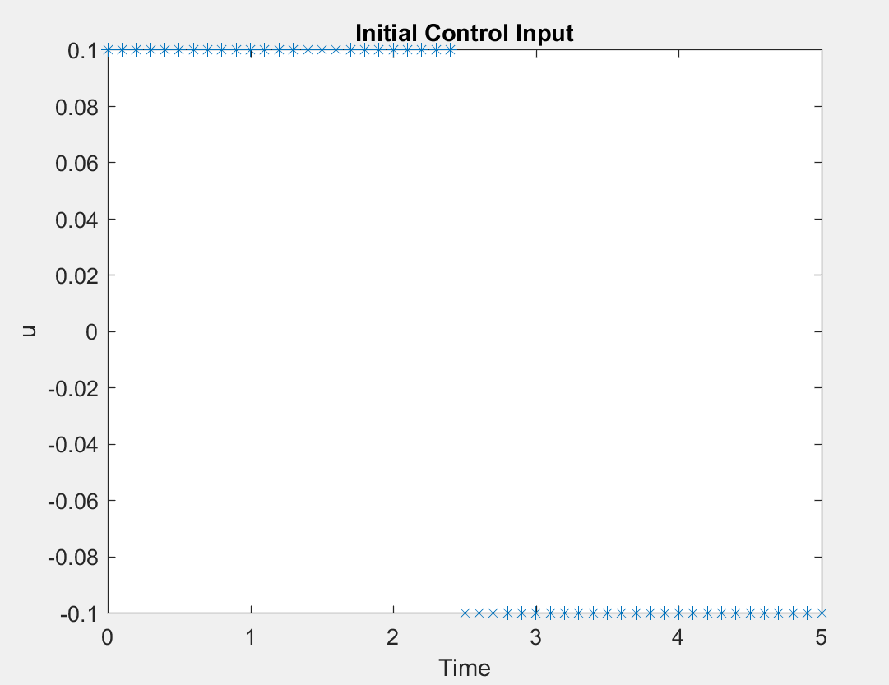

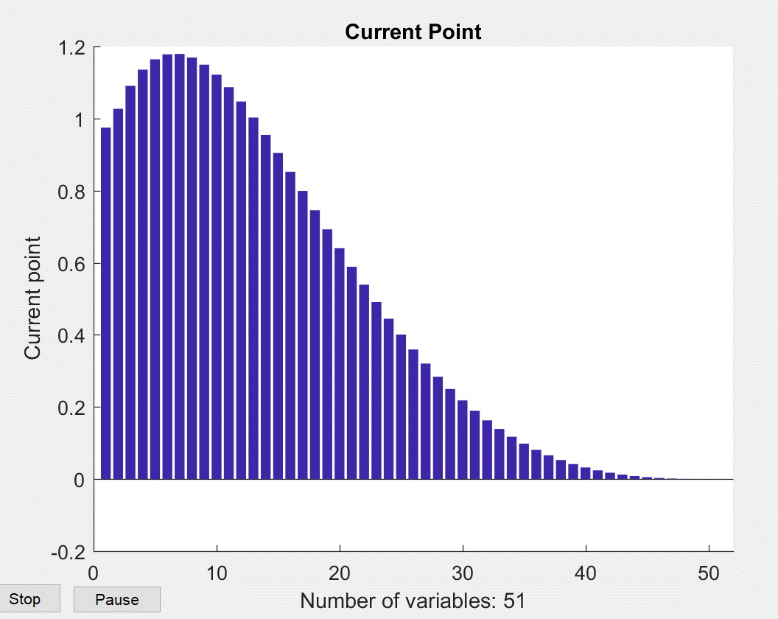

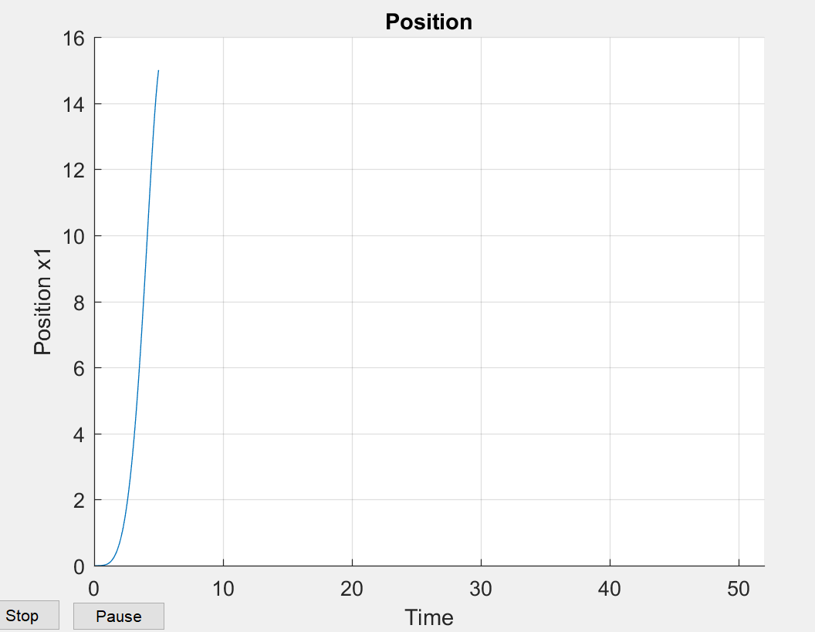

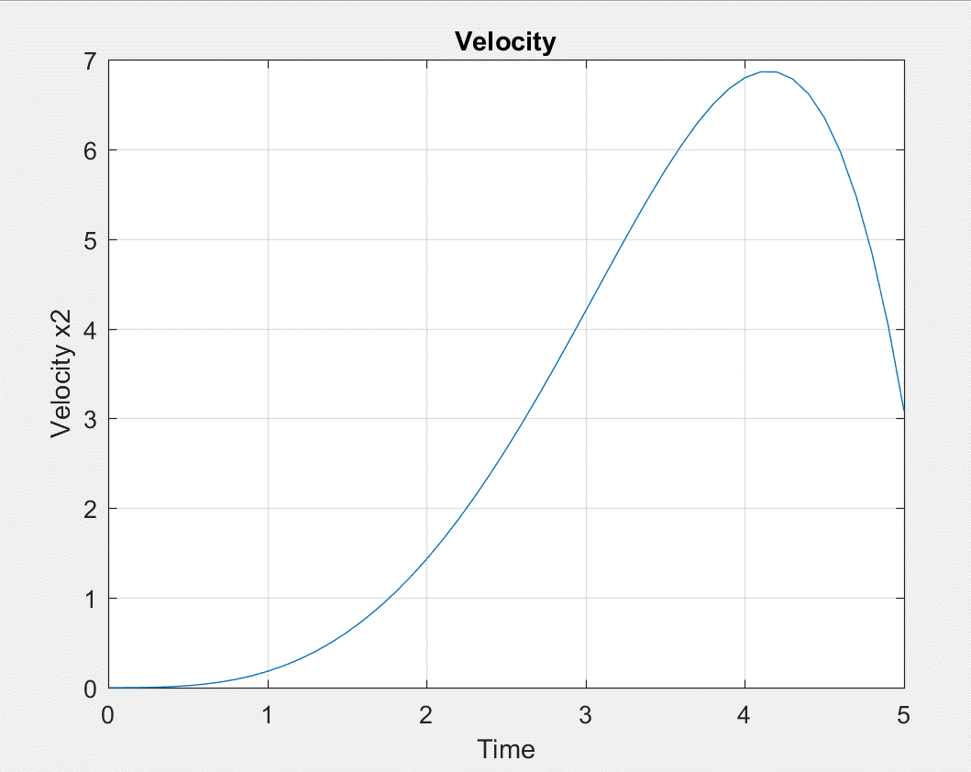

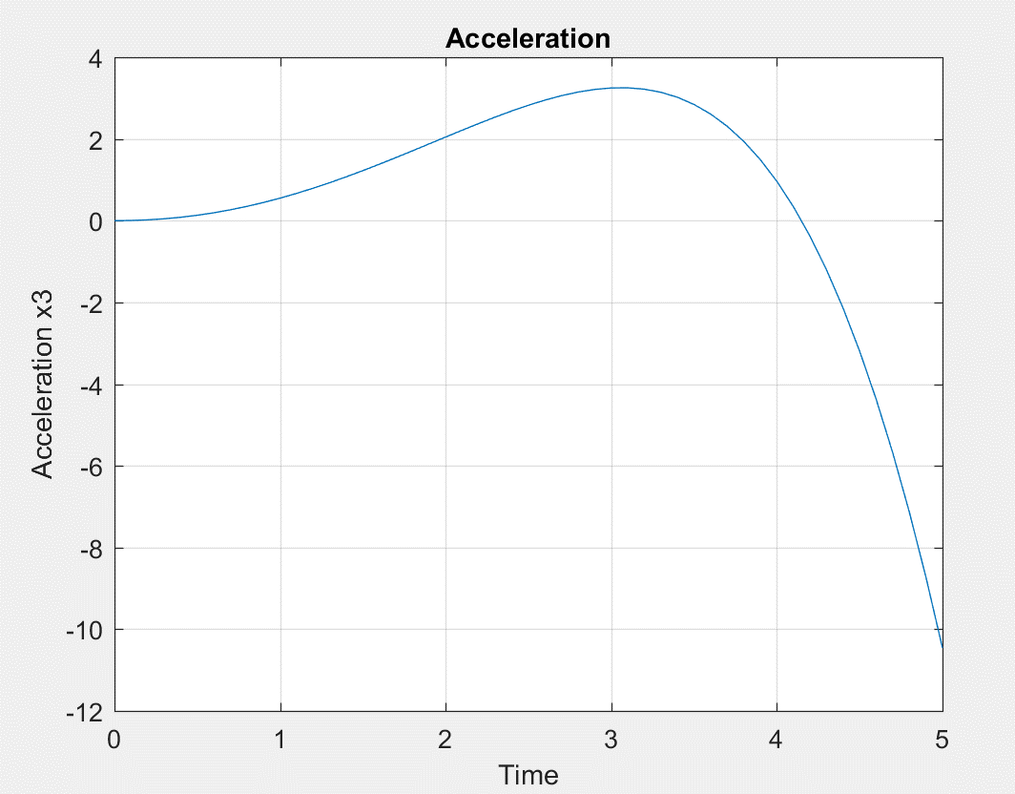

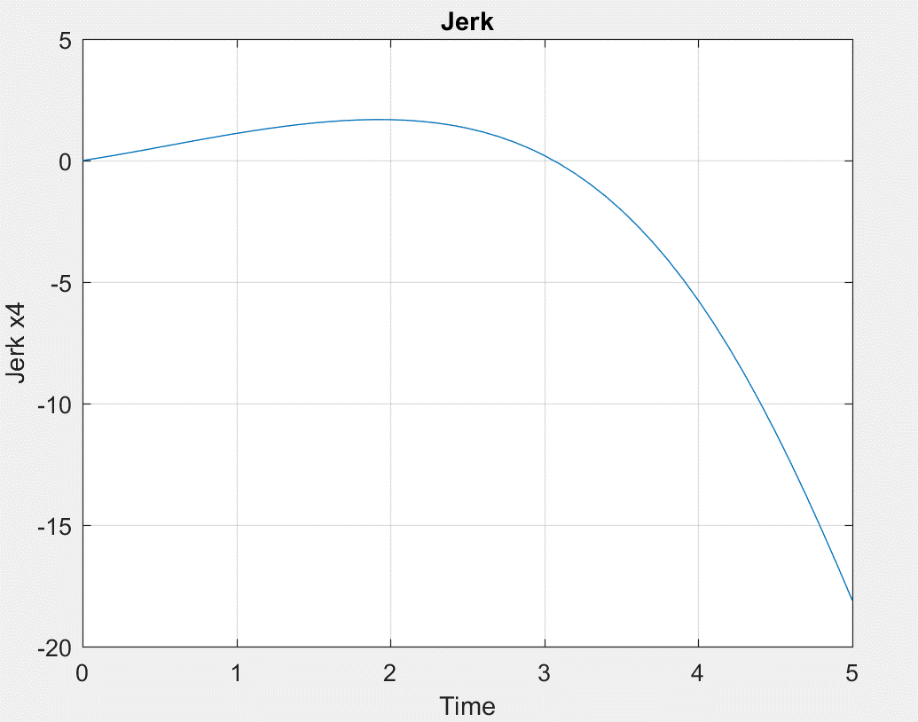

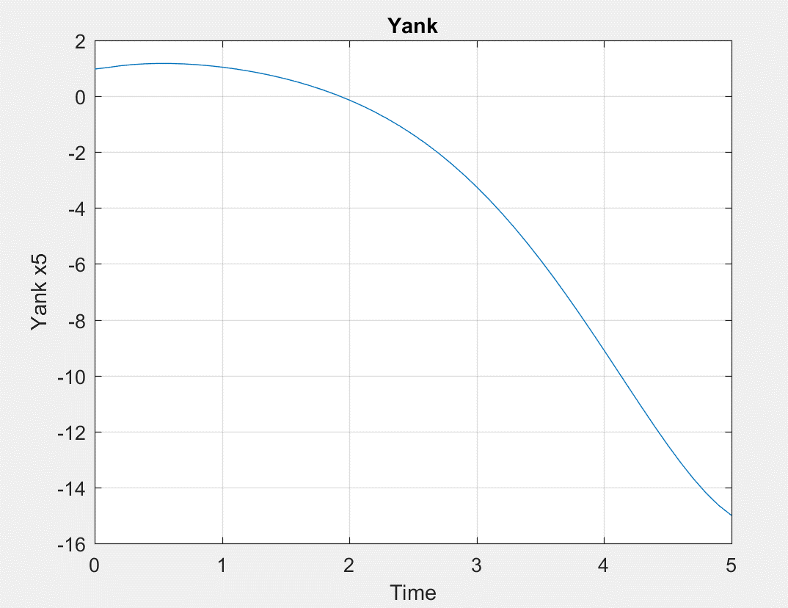

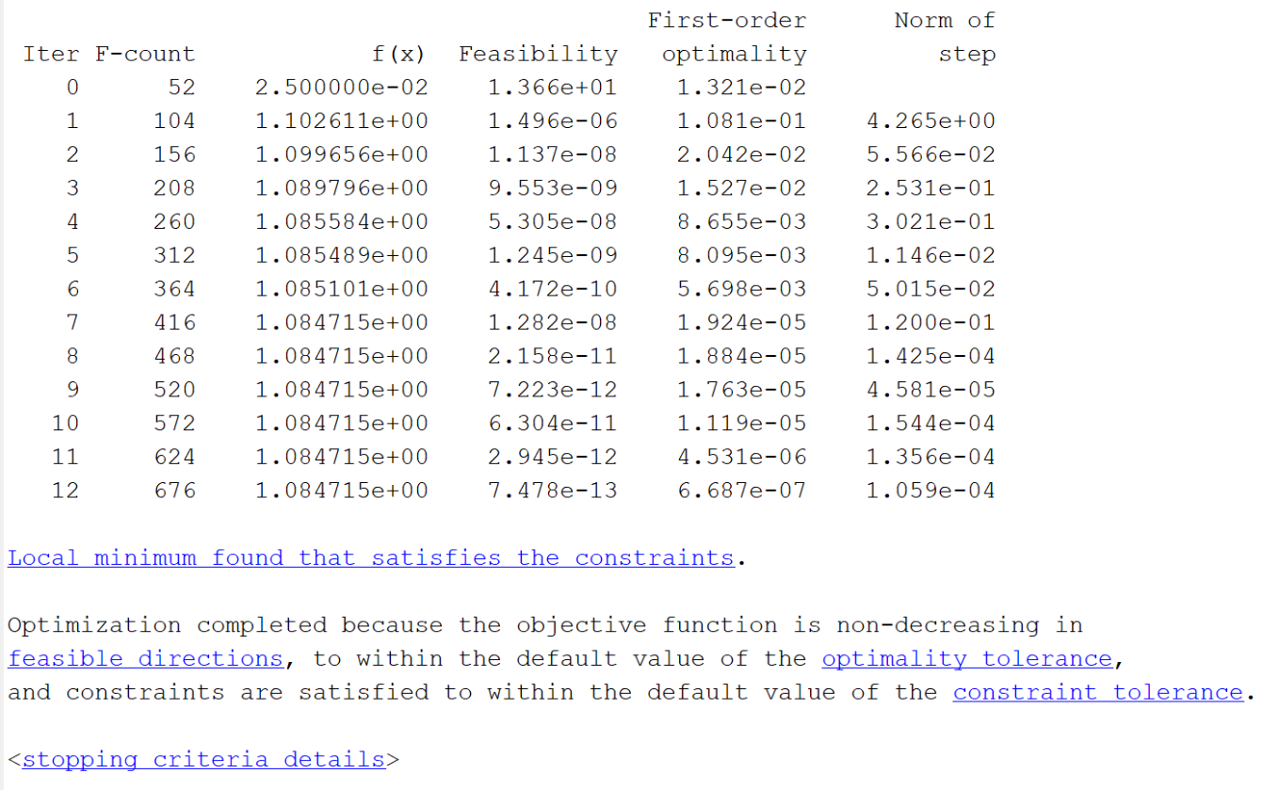

*The value of cost function is 1.084715 as per the above result.*

*With position and velocity as hard constraints*

function [cineq,ceq] = hw3p2constraint2(u)

cineq = [];

t = 0:0.1:5;

[tout,xout,yout] = sim('hw3p2',t',[],[t' u]);

% Position and velocity hard constraints

ceq(1) = 15 - yout(end,1);

ceq(2) = yout(end,2);

Result:

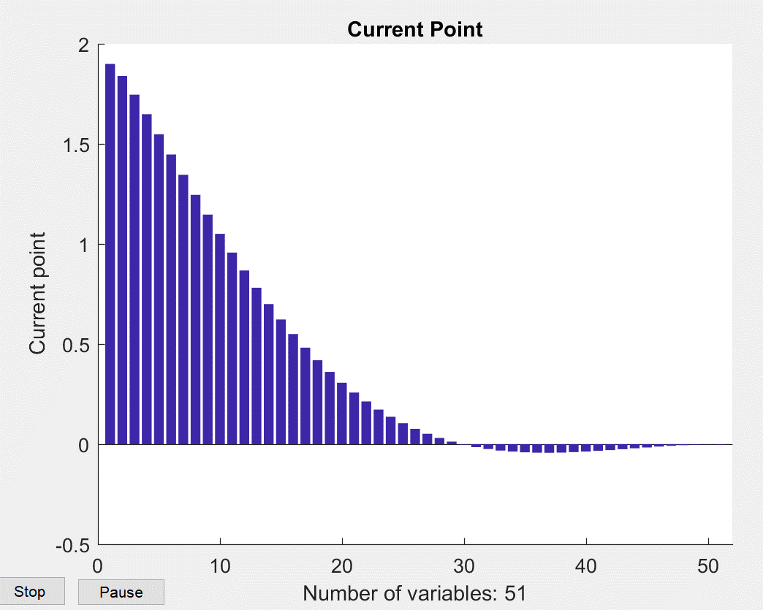

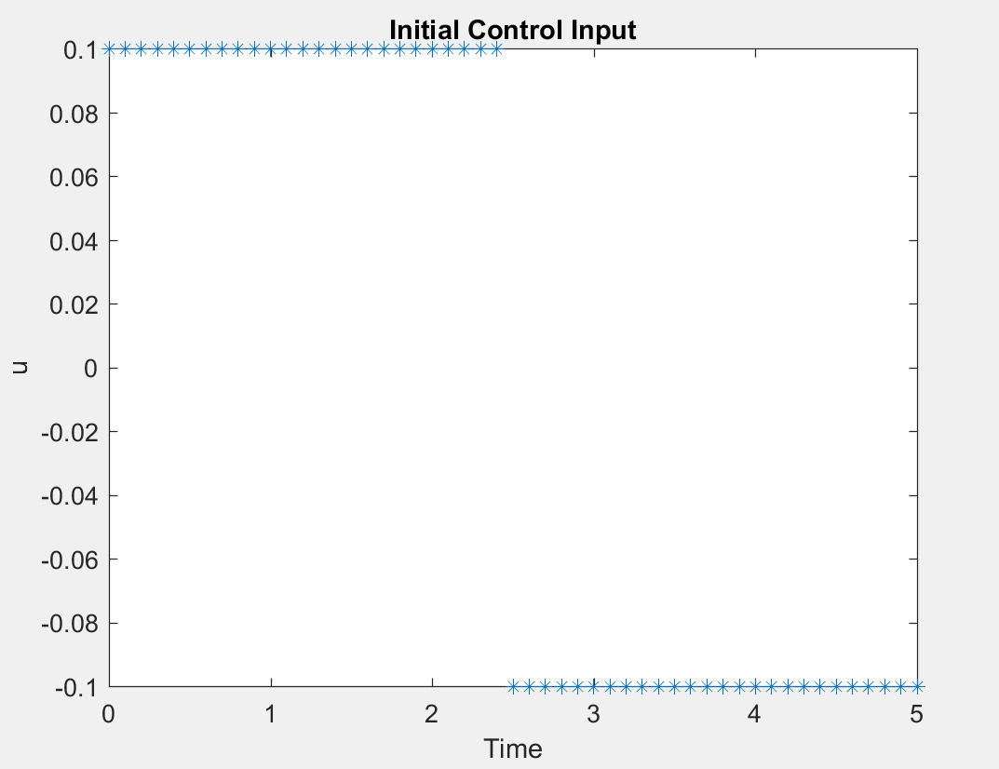

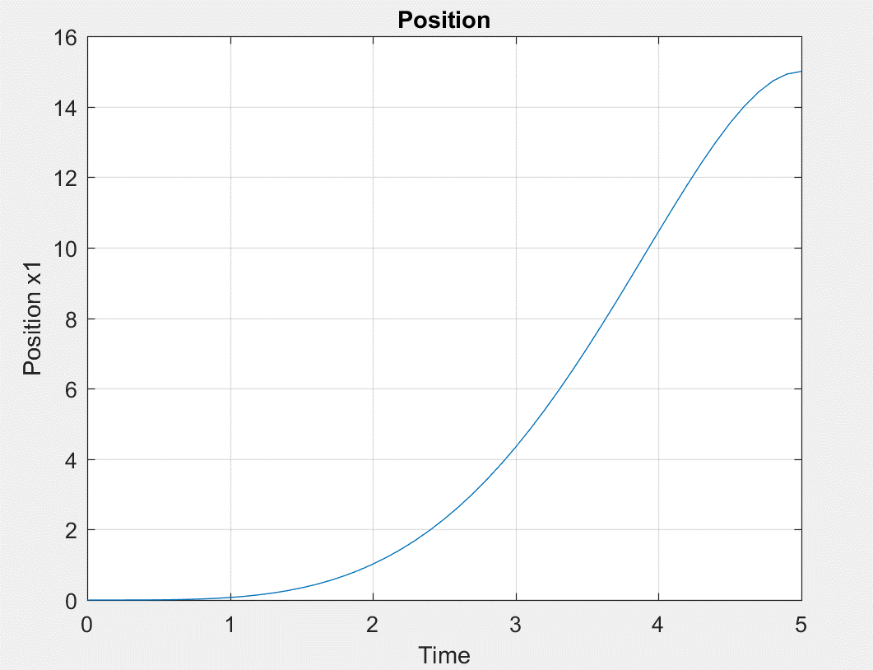

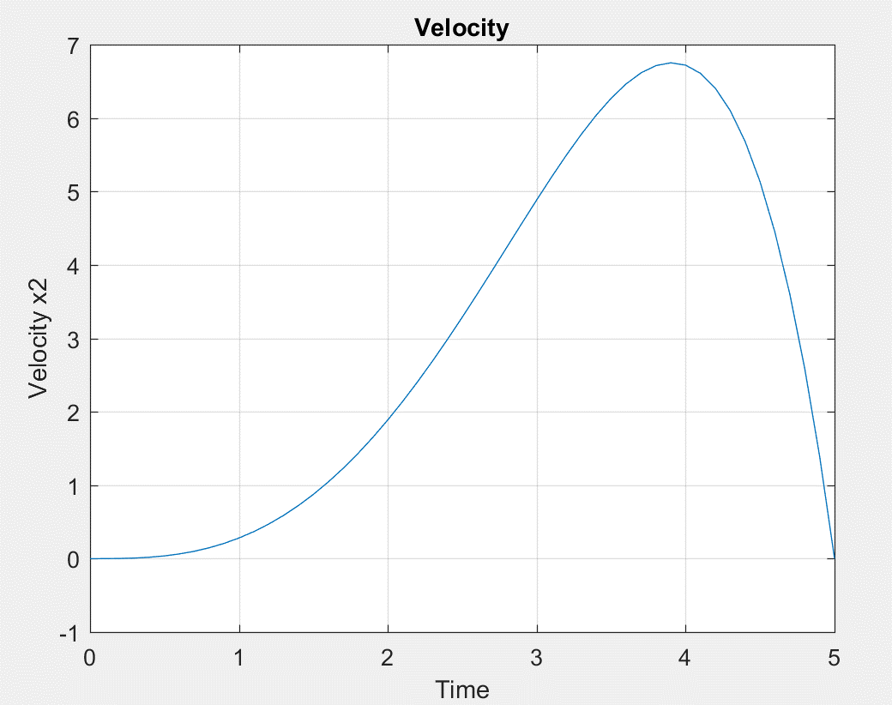

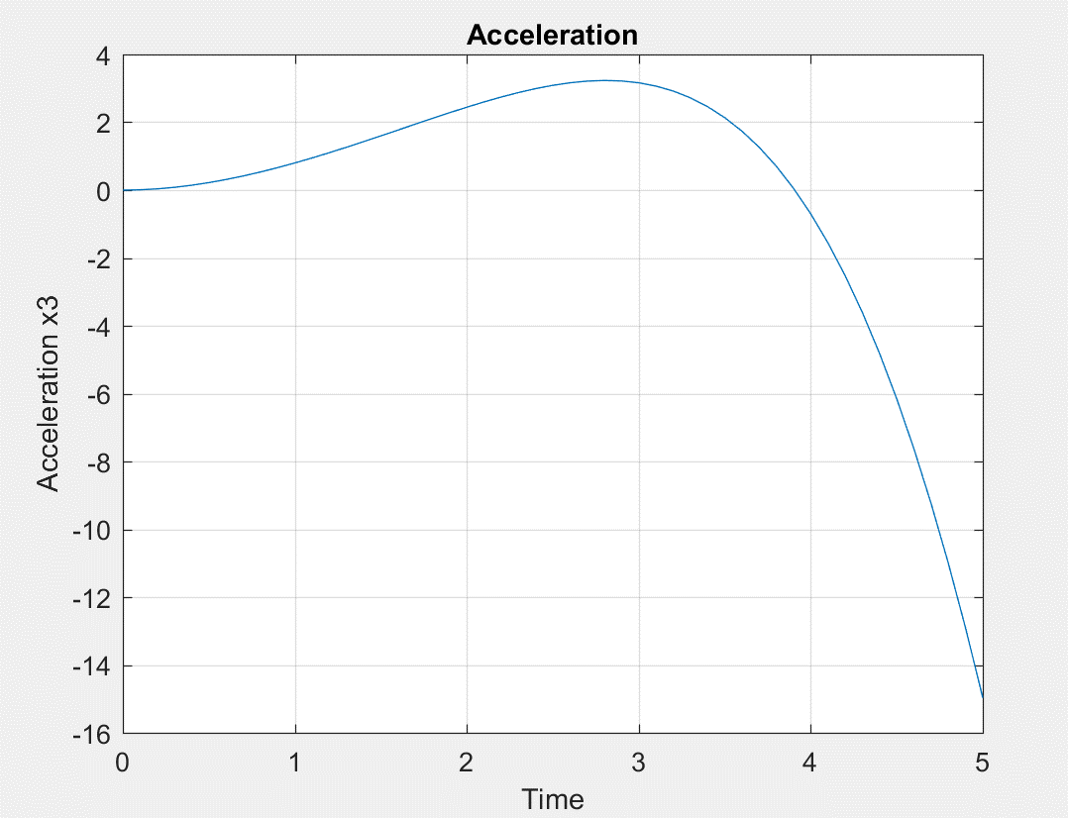

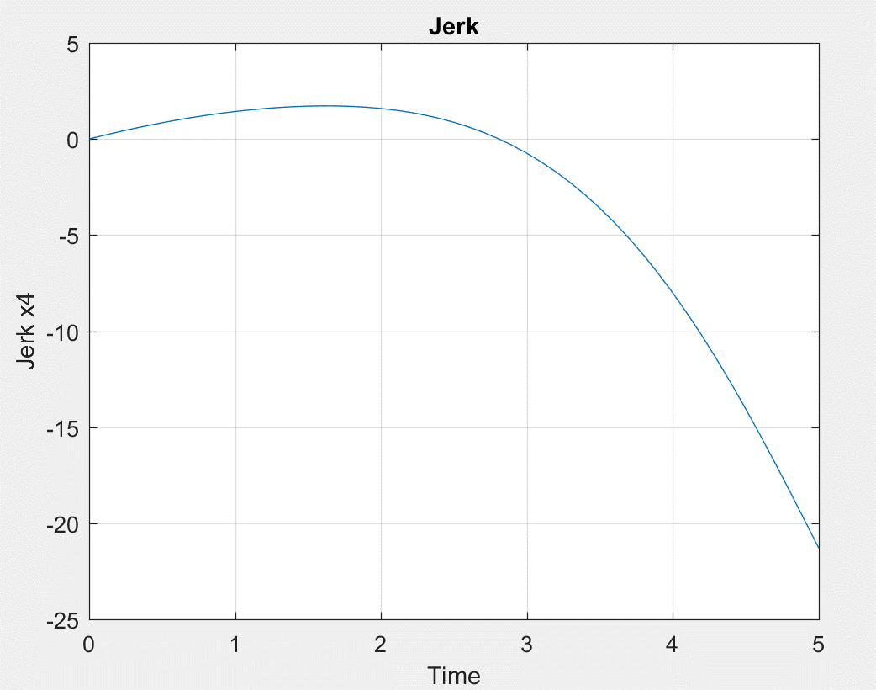

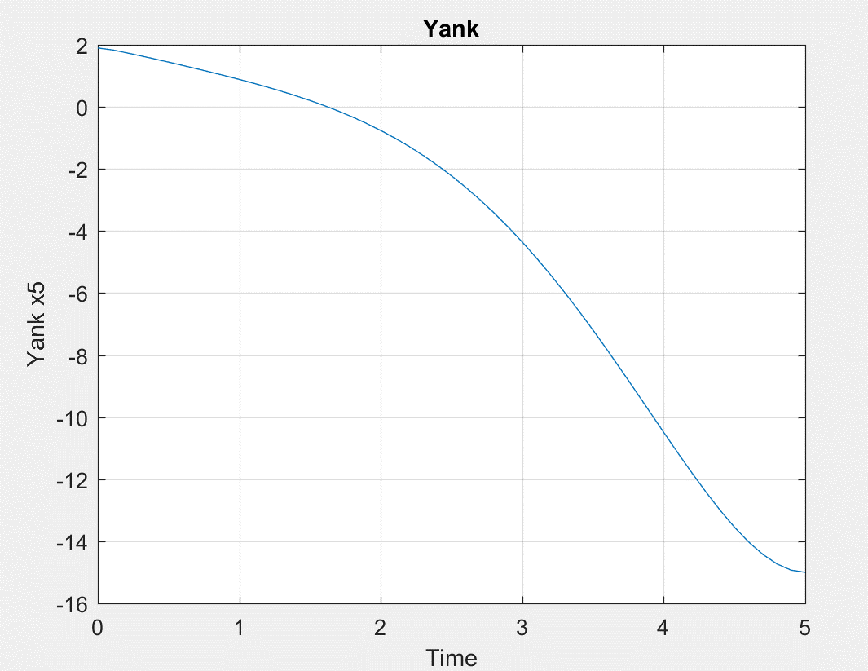

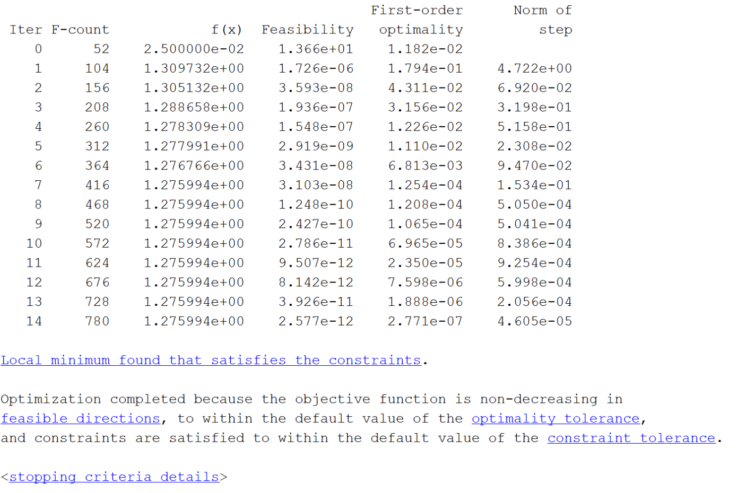

*The value of cost function as calculated from the above is1.275994.*

1. *With position, velocity and acceleration as hard constraints*

function [cineq,ceq] = hw3p2constraint3(u)

cineq = [];

t = 0:0.1:5;

[tout,xout,yout] = sim('hw3p2',t',[],[t' u]);

% Position, velocity and acceleration hard constraints

ceq(1) = 15 - yout(end,1);

ceq(2) = yout(end,2);

ceq(3) = yout(end,3);

end

Result:

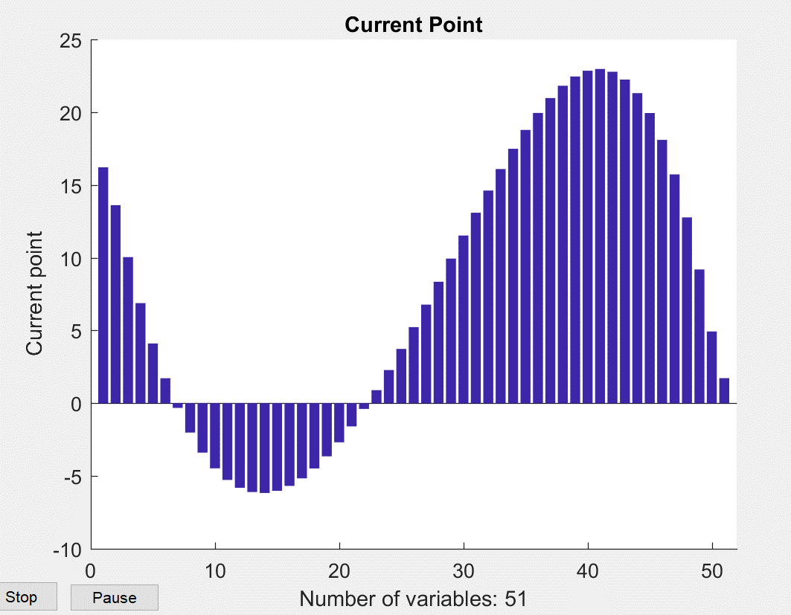

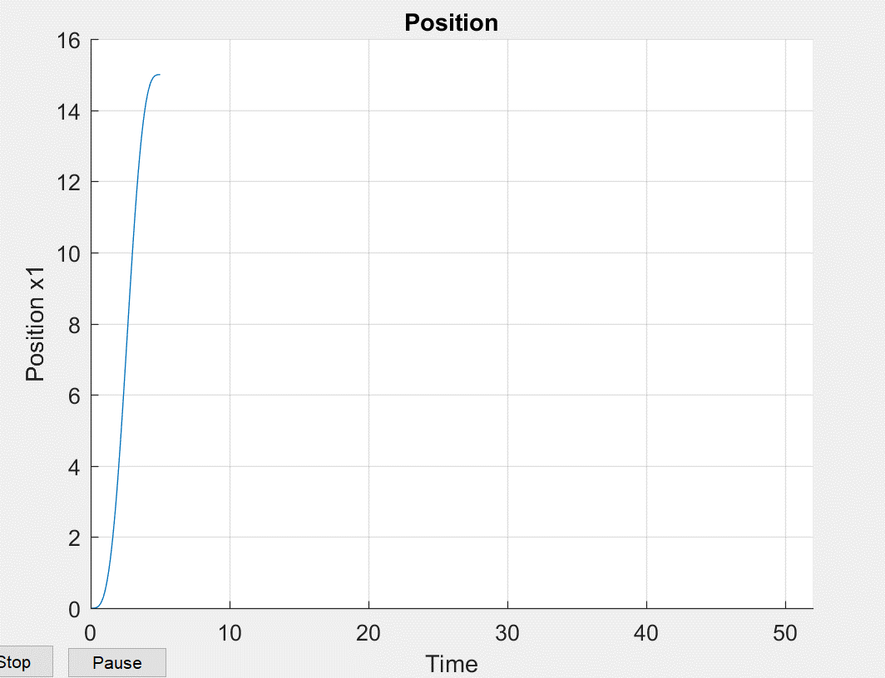

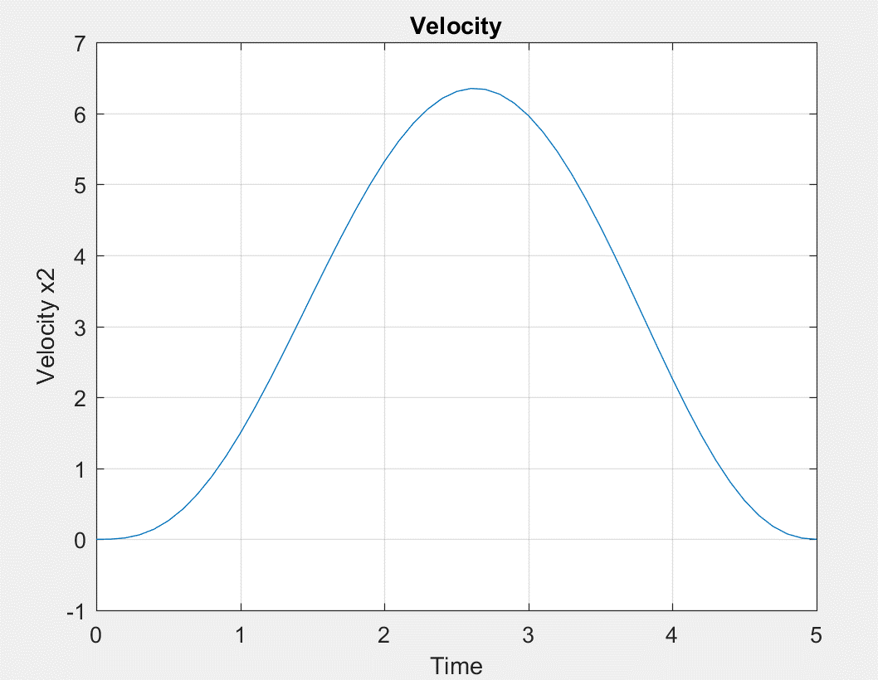

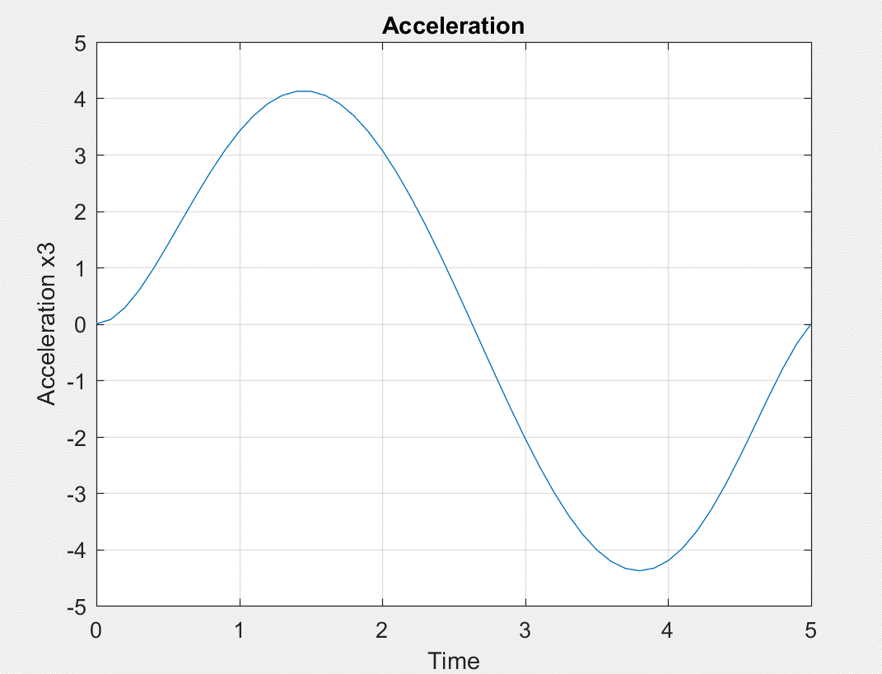

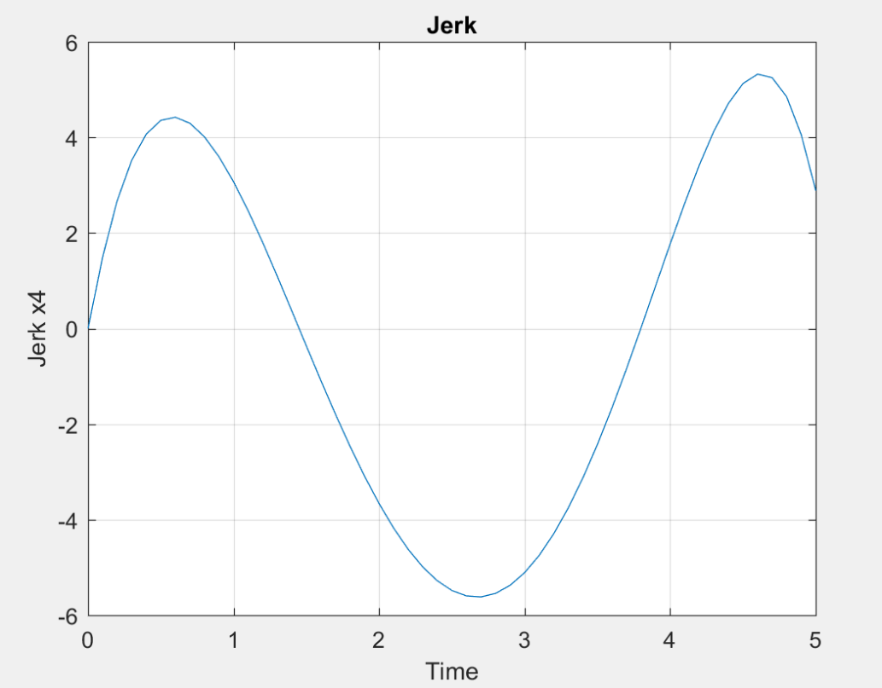

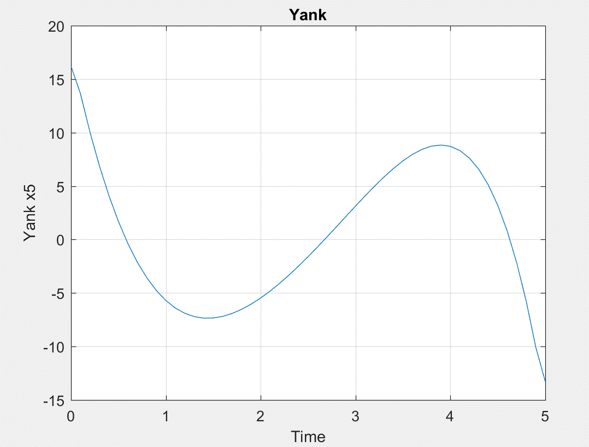

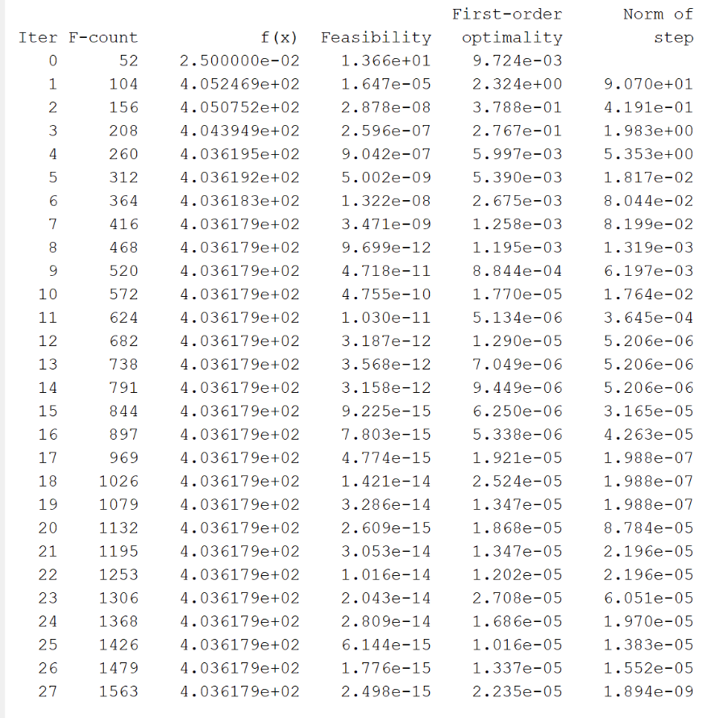

*The value of cost function as calculated from the above is 4.036179e+02.*

**d)**

*When position, velocity, acceleration and jerk are the hard constraints.*

function [cineq,ceq] = hw3p2constraint4(u)

cineq = [];

t = 0:0.1:5;

[tout,xout,yout] = sim('hw3p2',t',[],[t' u]);

% Position, velocity, acceleration and jerk hard constraints

ceq(1) = 15 - yout(end,1);

ceq(2) = yout(end,2);

ceq(3) = yout(end,3);

ceq(4) = yout(end,4);

end

Result:

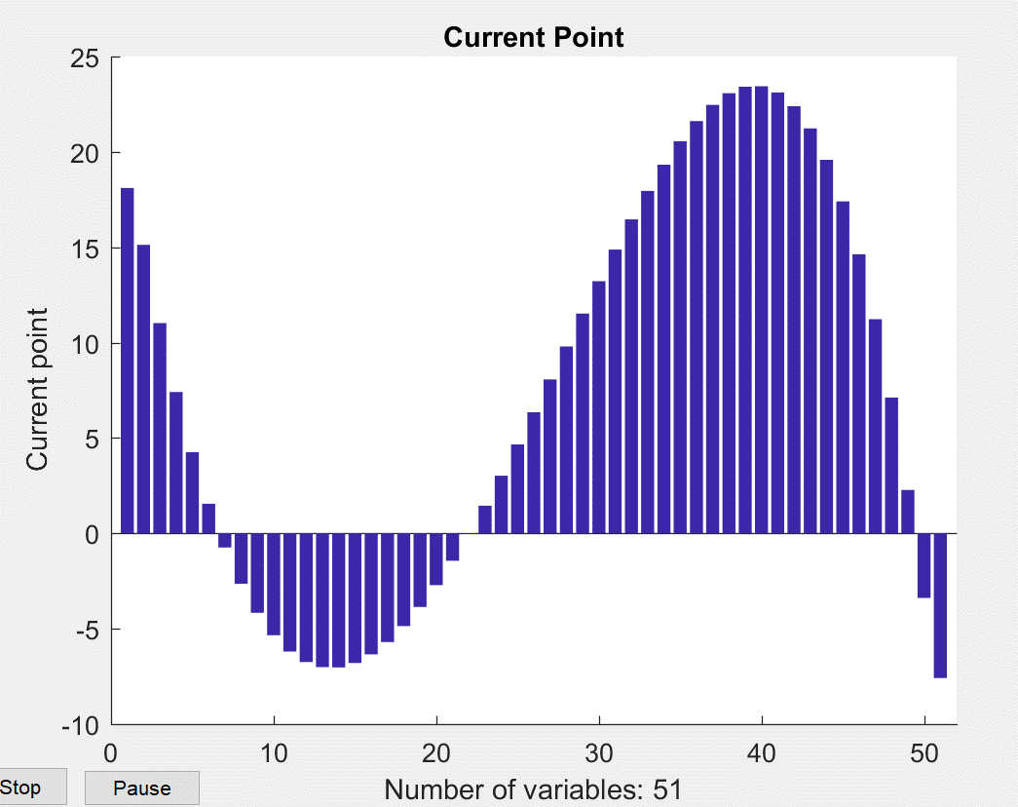

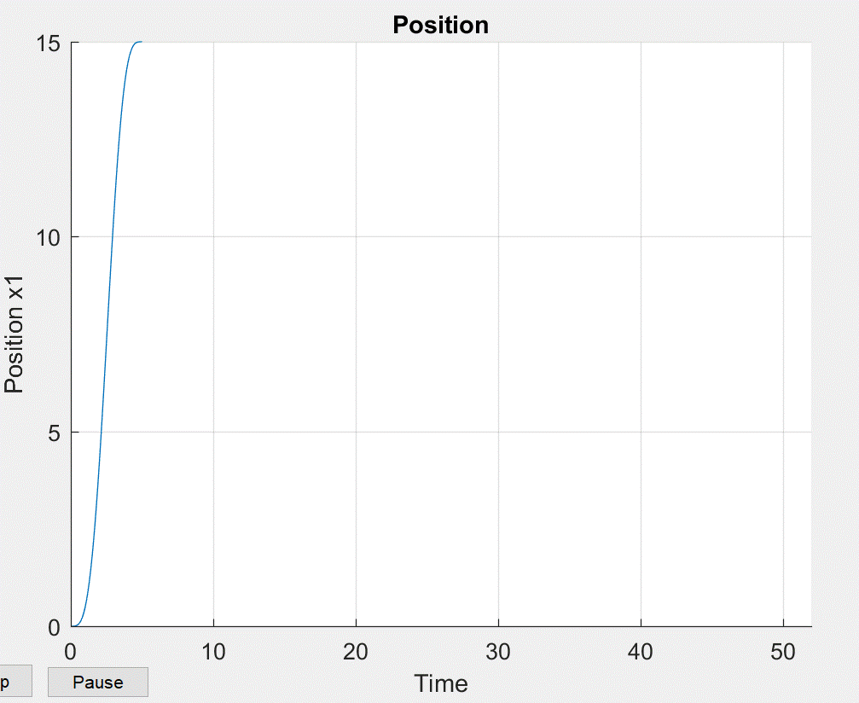

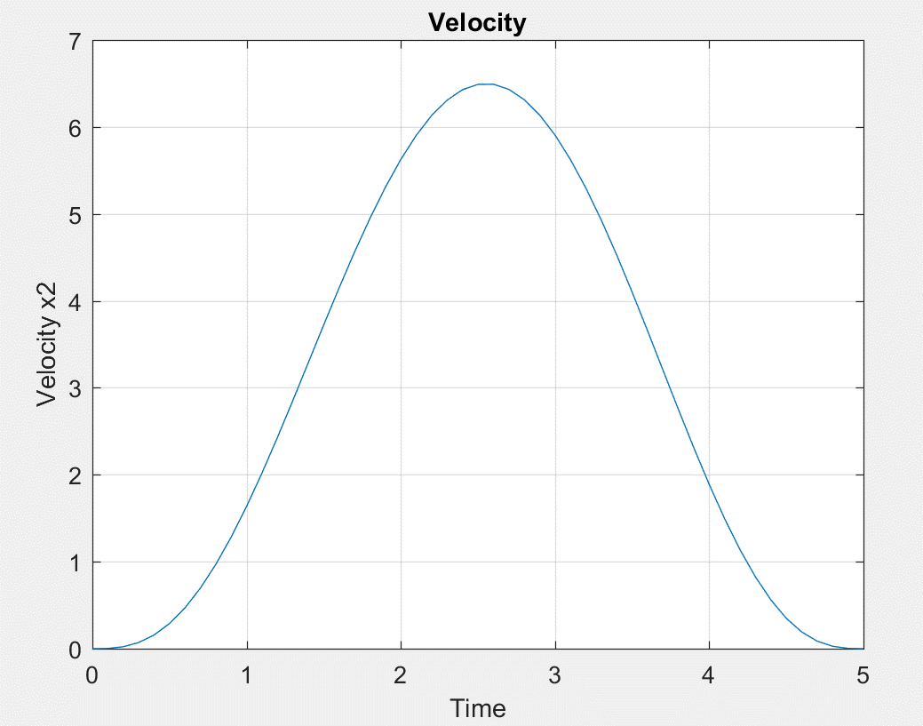

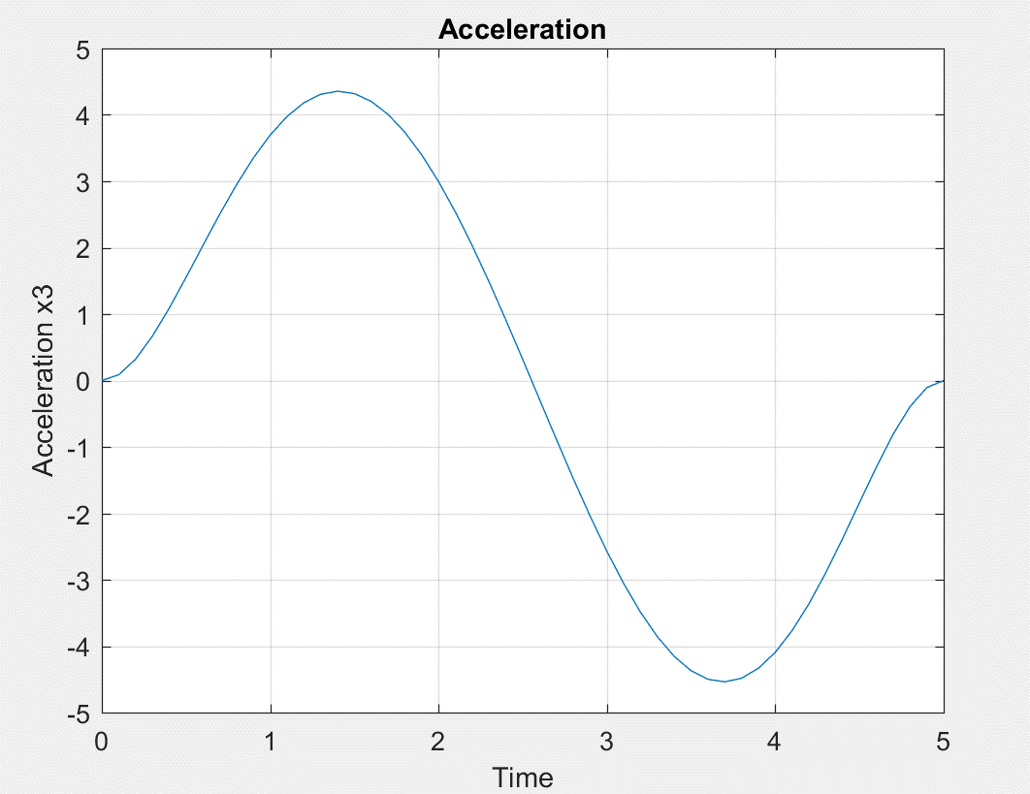

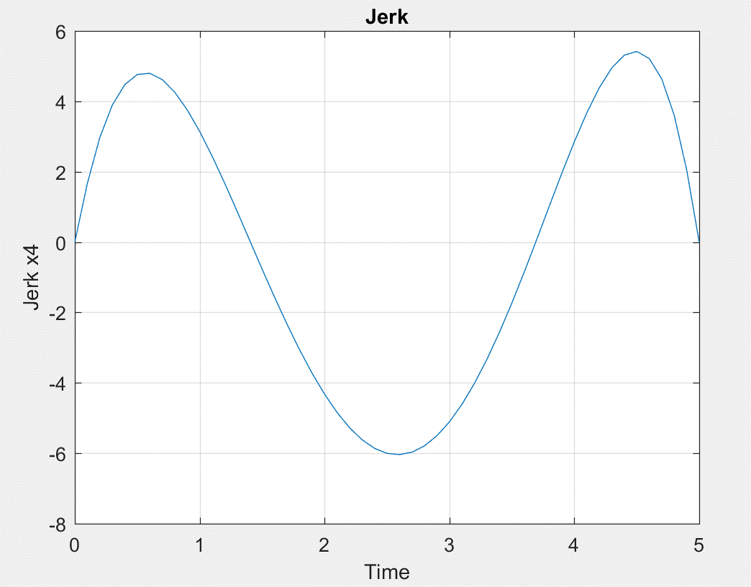

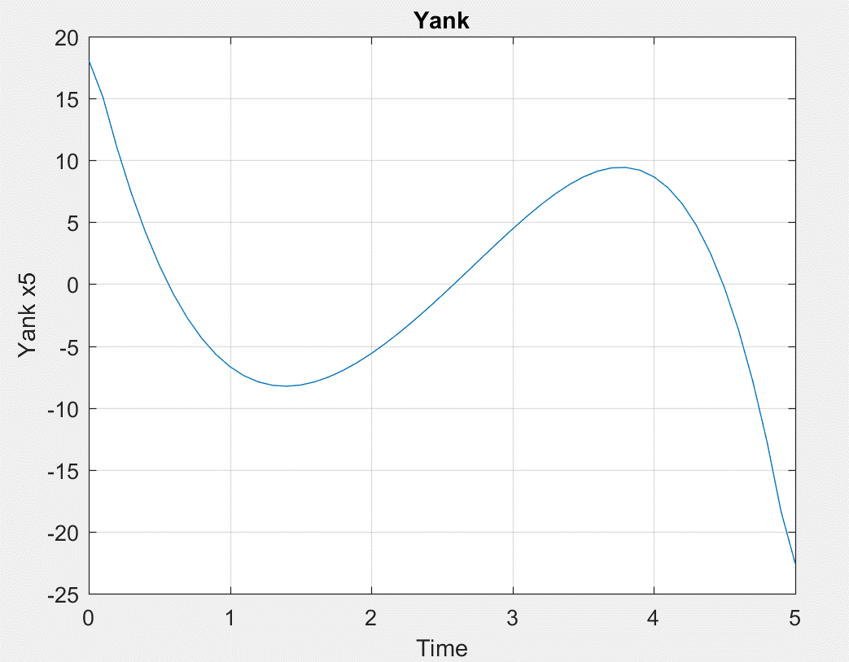

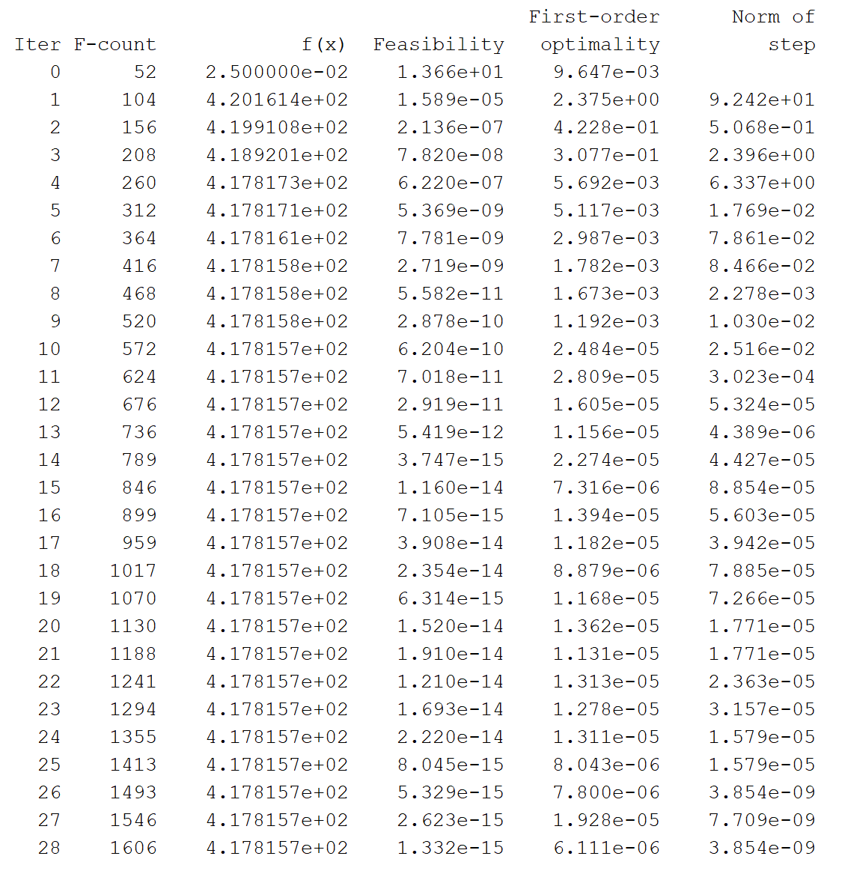

*The value of cost function calculated is 4.178157e+02 as calculated above.*

**e)**

*With position, velocity, acceleration, jerk and yank as the hard constraints*

function [cineq,ceq] = hw3p2constraint5(u)

cineq = [];

t = 0:0.1:5;

[tout,xout,yout] = sim('hw3p2',t',[],[t' u]);

% Position, velocity, acceleration and jerk hard constraints

ceq(1) = 15 - yout(end,1);

ceq(2) = yout(end,2);

ceq(3) = yout(end,3);

ceq(4) = yout(end,4);

ceq(5) = yout(end,5);

end

Result:

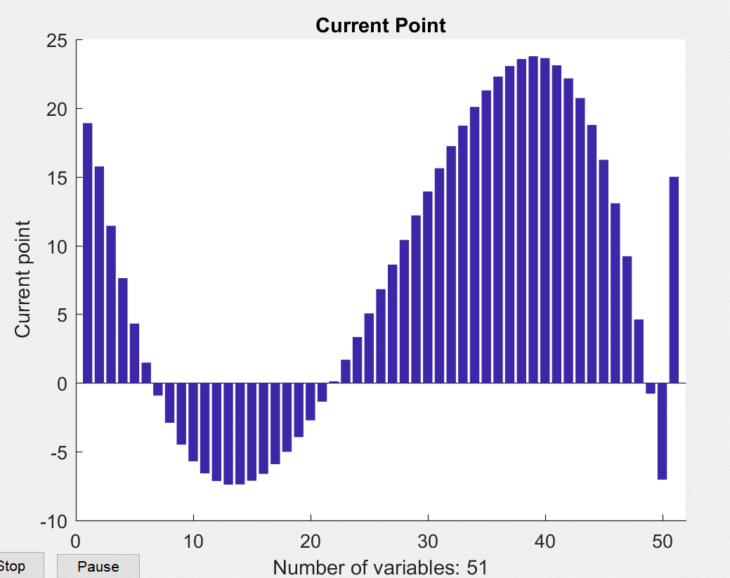

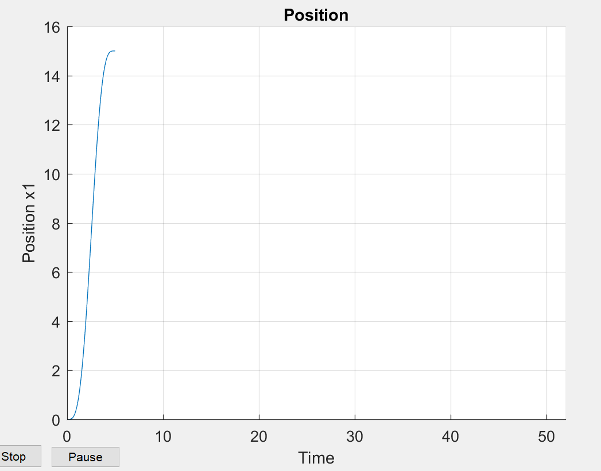

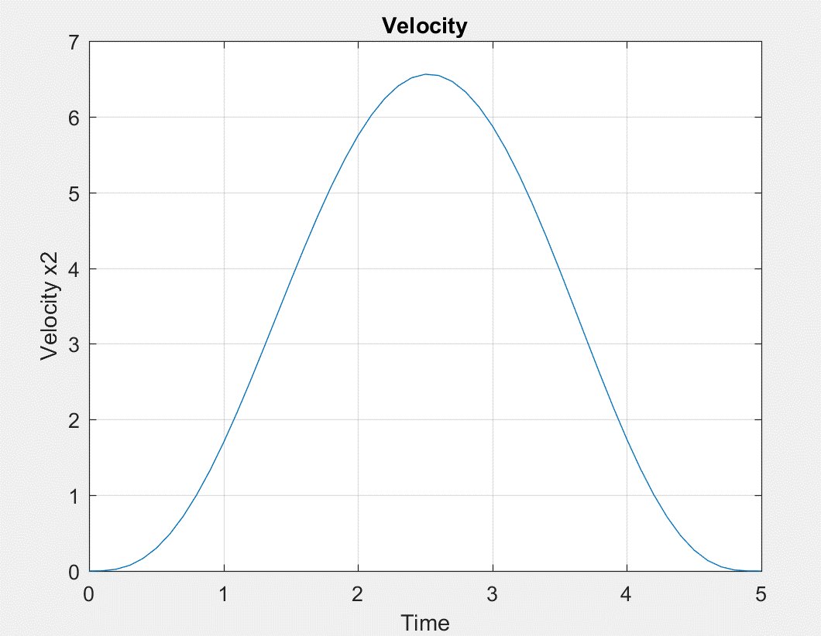

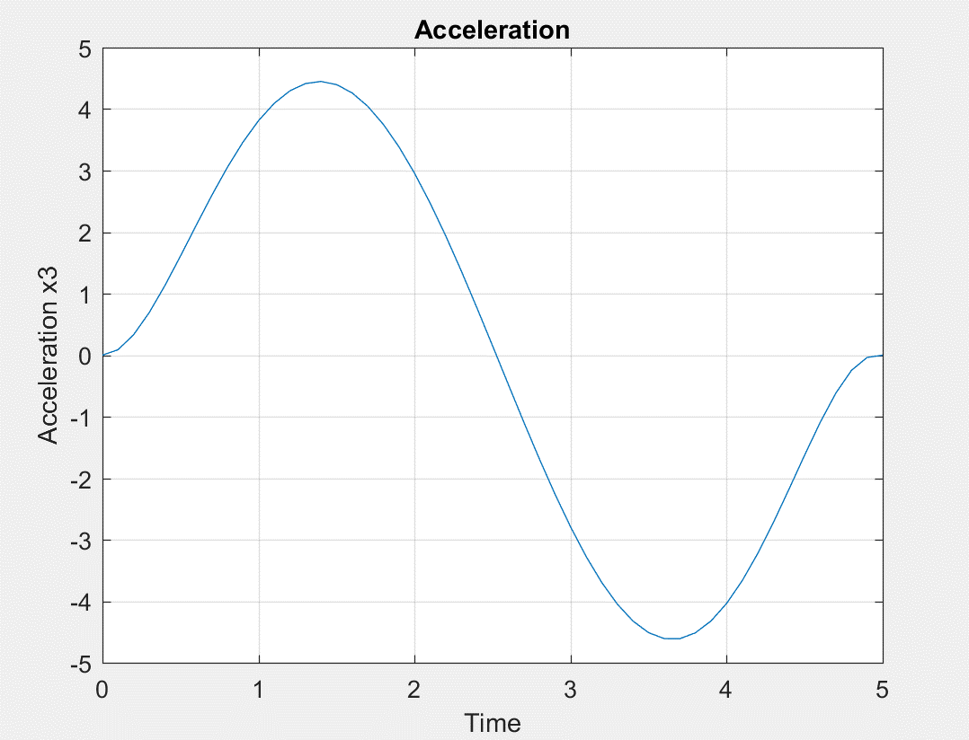

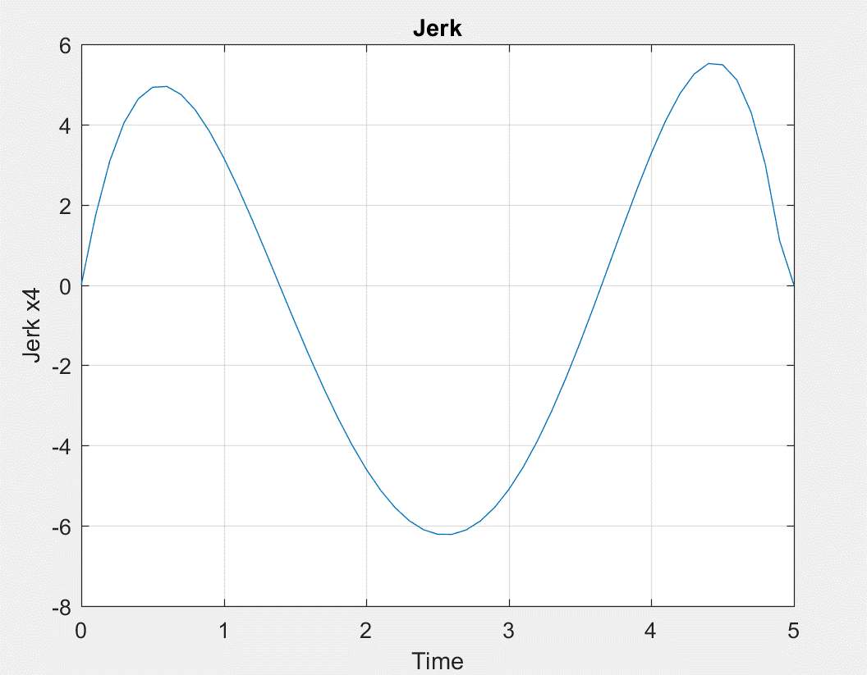

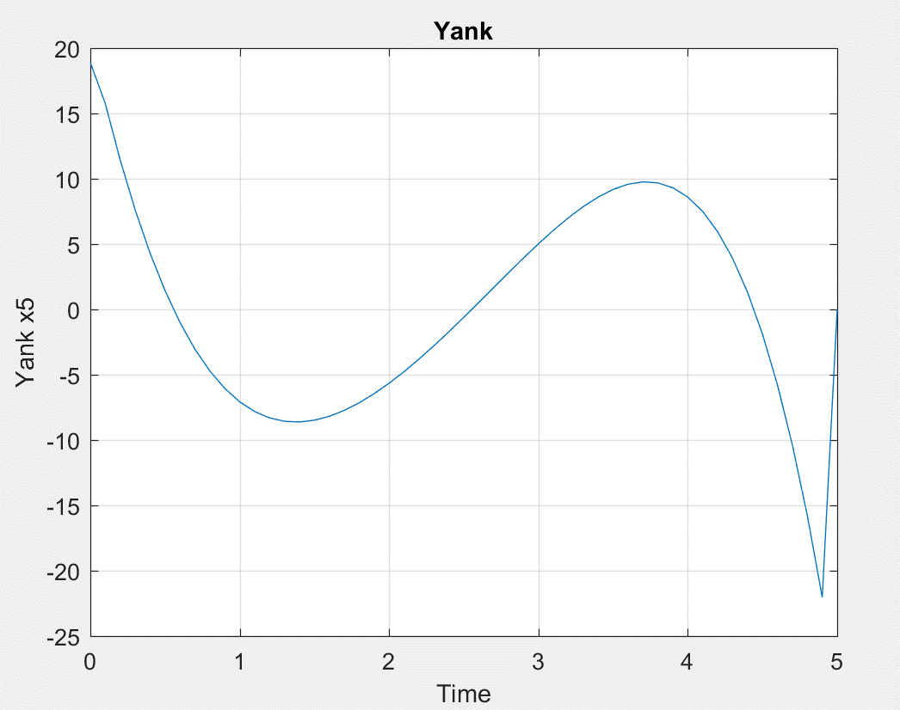

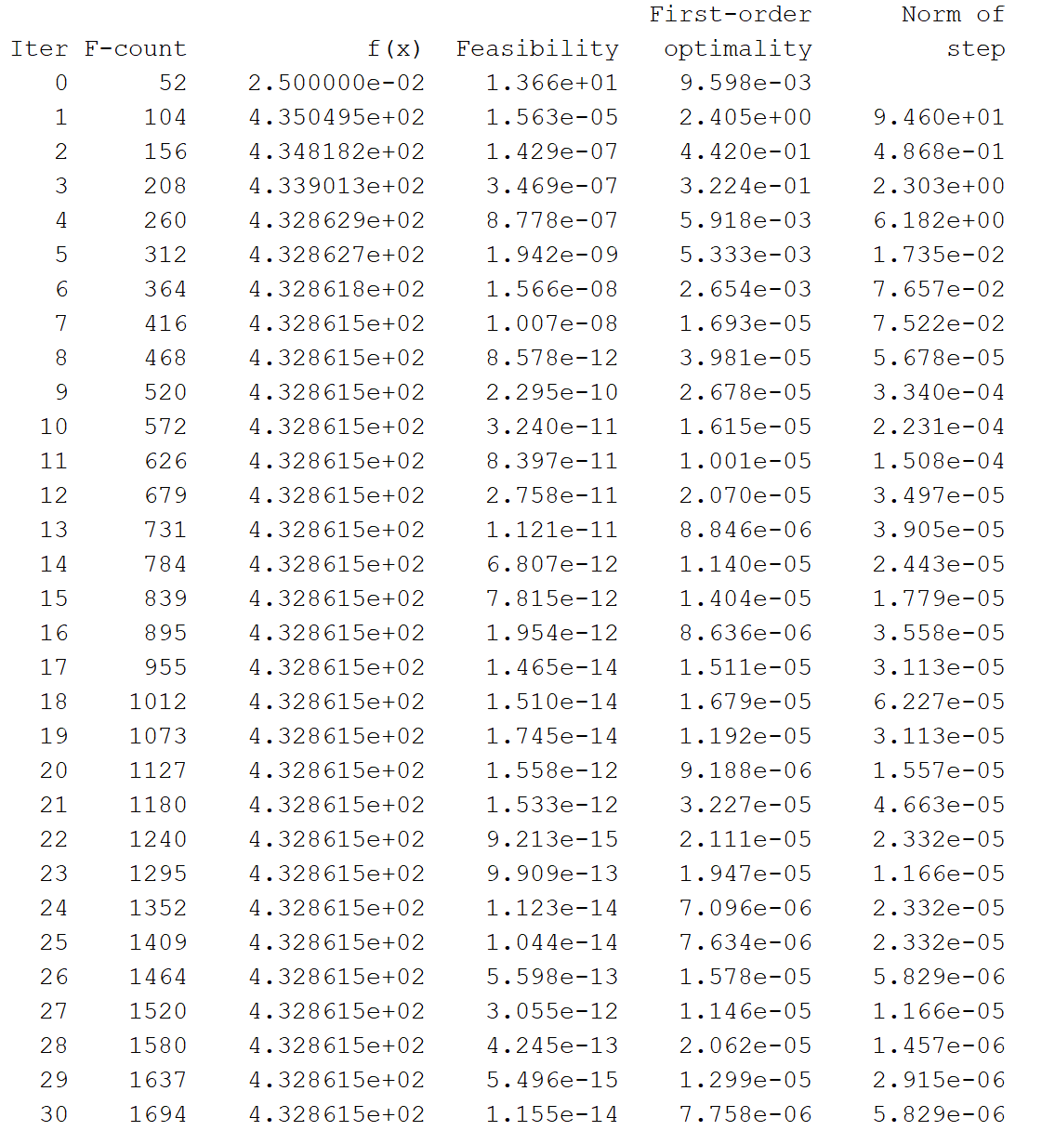

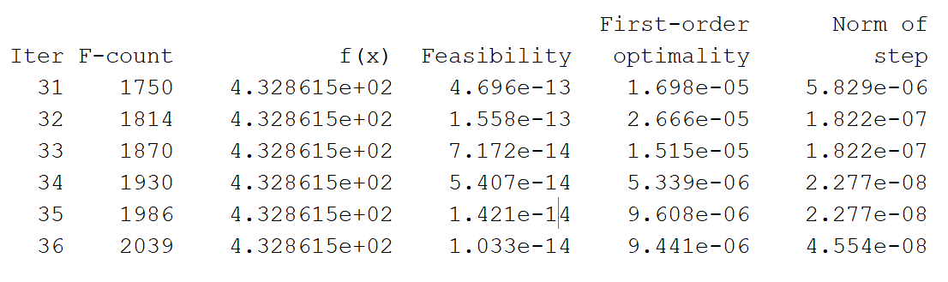

*The value of cost is 4.328615e+02 according to the above results.*

f) Thus, it can be observed that the value of cost increases as more constraints are added to the constraint function.

|  |  |
| --- | --- |
| **Constraint** | **Cost** |
| Position | *1.084715* |
| Position, velocity | *1.275994* |
| Position, velocity, acceleration | *403.6179* |
| Position, velocity, acceleration, jerk | *417.8157* |
| Position, velocity, acceleration, jerk, yank | *432.8615* |